bus helicopter motorcycle plane taxi train trolley ship
1.Look and write
 | 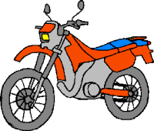 | 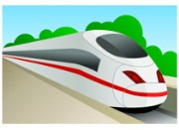 | 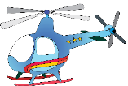
………………………… | ………………………… | ………………………… | …………………………
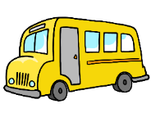 | 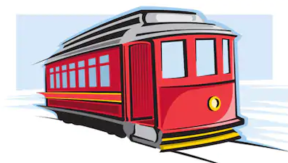 | 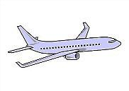 | 
………………………… | ………………………… | ………………………… | …………………………
Yes , it is . | No , it isn’t.
2. Write
 | 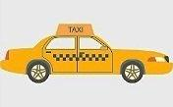 | 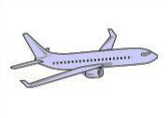
Is it a bus ? | Is it a plane? | Is it a helicopter ?
………………………… | ………………………… | …………………………
 | 
Is it a motorcycle ? | Is it a ship ? | Is it a trolley ?
………………………… | ………………………… | …………………………
3. Write There was or There were.
- …………..a supermarket near my house | - …………….a park in our town fifty ago.
- ……………... many cinemas in 1925. | - …………… some pictures in that museum
- In 1957 ………………….many trees in this street. | - ………….........many people in the library yesterday.
- ………………….. a fantastic shopping center in the town. | - ………………….. a small shop between the bank and the supermarket
- ………………….. a bank near my house. | - ………………a lightning storm last night.
- ………………….. a ghost in the house | - In 1958 , ………………….. three parks
- ………………….. trolleys in our town one hundred years ago. | - ………………….. a museum in our town one hundred years ago.
- ………………….. lots of bikes in our town one hundred years ago. | - ………………….. some old cars in the museum.
- .………………….. a swimming pool at the hotel. | - In 2008 , ……….. two train stations in our town.
- In 2016 , ………………….. three big restaurants in our town. | - In the past , ………………….. four banks in our town.
- In the past , ………………….. lots of trees in the park. | - …………….. a bookshop next to the museum.
4. Look at the pictures and write sentences. Use there is/ there are and there was/ there were
Eg: There wasn’t a supermarket fifty years ago. Now, there is a big supermarket and a market
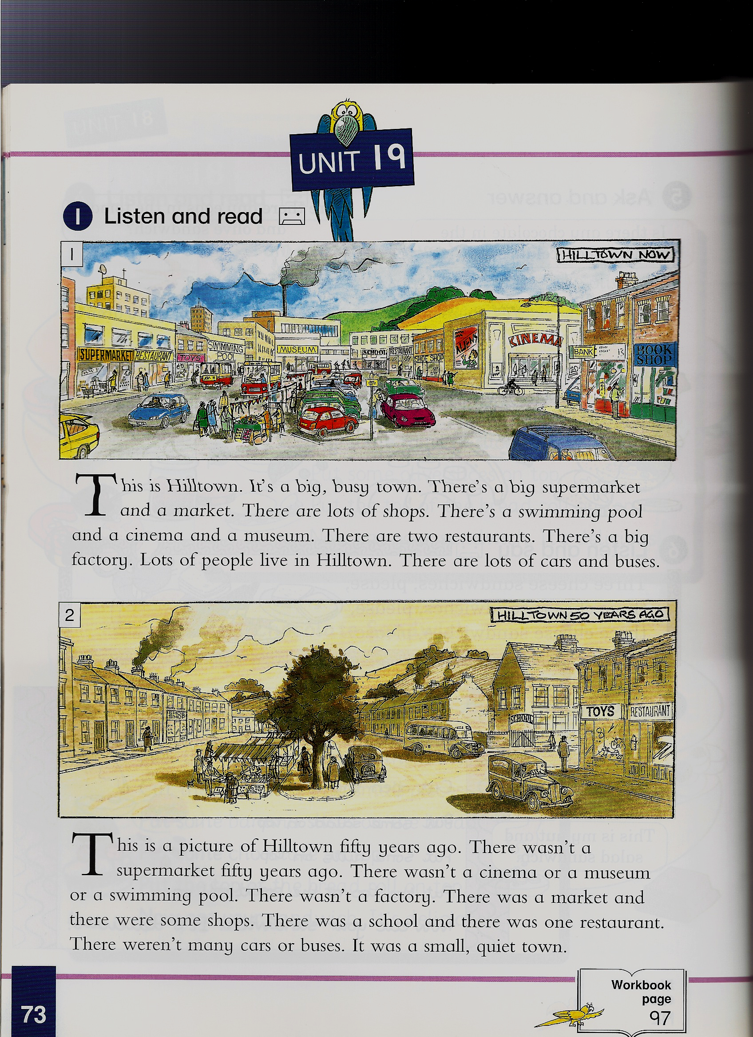

- ____________________________________________________________________
- ____________________________________________________________________
- ____________________________________________________________________
- ____________________________________________________________________
- ____________________________________________________________________
- ____________________________________________________________________
7-____________________________________________________________________
5. Look at the picture and answer the questions with :
Yes , there was. | No, there wasn’t. | Yes , there were. | No, there weren’t.

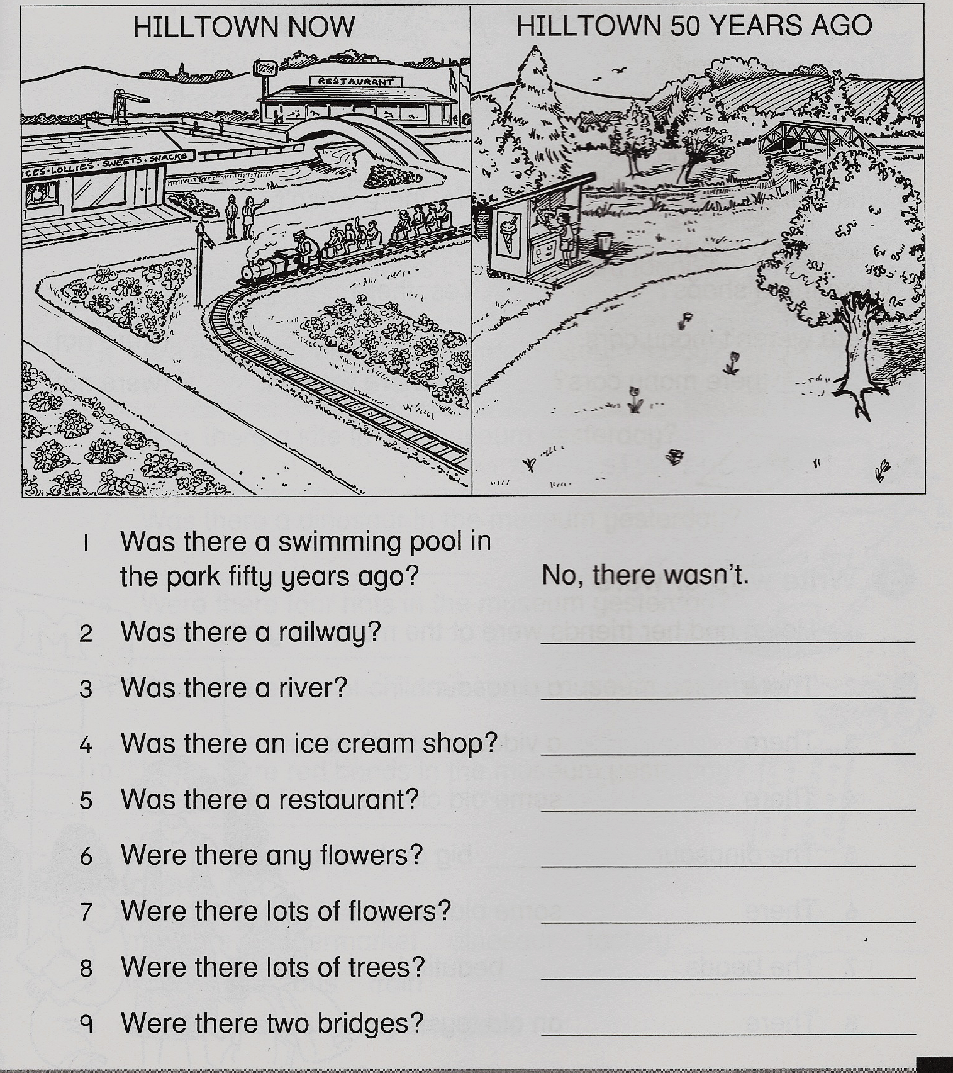

- Was there a swimming pool in the park fifty years ago? ________________
- Was there a railway? __________________________
- Was there a river? __________________________
- Was there an ice cream shop? __________________________
- Was there a restaurant? __________________________
- Were there any flowers? __________________________
- Were there lots of flowers? __________________________
- Were there lots of trees? __________________________
- Were there two bridges? __________________________
6.Look at two pictures and describe with :

There is | There isn’t | There was | There wasn’t

Yesterday | Today
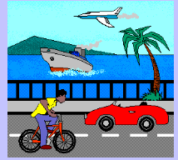 | 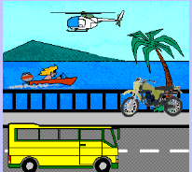
Yesterday / plane / helicopter | Today / boat / ship
Yesterday There was a plane but there wasn't a helicopter. | …………………………………………………….
Yesterday / car / bus | Today / helicopter / plane
………………………………………………………… | …………………………………………..
Yesterday / bicycle / motorbike | Today / bus / car
…………………………………………………………… | ………………………………………………………
Yesterday / ship/boat | Today / motorbike / bicycle
………………………………………………………… | ………………………………………………
7.Write with There is /There are /There was or There were.
1……………………………… three apples on the table yesterday.
2. ……………………………… three apples on the table today.
3. ……………………………… a cat near the school today.
4. ……………………………… a cat near the school yesterday.
5. ……………………………… some people in this street 3 days ago.
6. Yesterday ……………………………… only one banana in my bag.
7. ……………………………… only 15 people in this bus today.
8. ……………………………… three thieves in the bank yesterday.
9. ………………………………no policeman in the bank yesterday.
10. ……………………………… some games in this shop now.
11. ……………………………… a match yesterday.
12 ……………………………… a lot of girls in the playground yesterday.
14 ………………………………many people in the concert yesterday.
15. ………………………………only one car there last Sunday.
16. ……………………………… an electricity in our village ten years ago.
17. ……………………………… lots of people in the street two days ago.
18 ……………………………… many policeman at the city center yesterday afternoon.
19. ……………………………… many teenagers at the cinema yesterday morning.
8.Describe two pictures with :
There was | There were | There is | There are
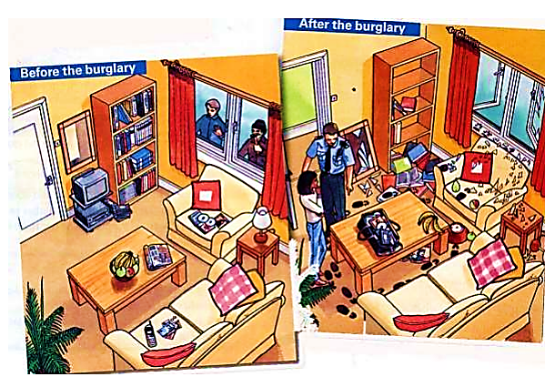
Ex:There was a mirror on the wall before the burglary, but there isn’t a mirror on the wall now.
- ………………………………………………………………………………………
- ………………………………………………………………………………………
- ………………………………………………………………………………………
- ………………………………………………………………………………………
- ………………………………………………………………………………………
- ………………………………………………………………………………………
- ………………………………………………………………………………………
9.Fill in the blanks with is or are in the picture A and was or were in the picture B
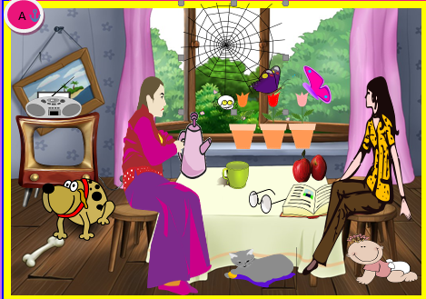 | 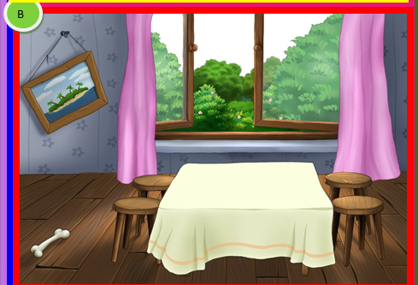
1.There ______ a web on the window.  2. There _____ a big spider in the web.  3. There _____ an old TV set in the corner of the room.  4. There ______ a radio on the TV set.  5. There _____ three flowers in pots on a window sill.  6. There _____ two butterflies on the flowers.  7. There _____a fat dog with a bone.  8. There _____ a green cup on a table.  9. There _____ two big red apples on the table.  10. There _____ a thick book in front of the apples.  11. There _____ glasses next to the book.  12. There _____two chairs in the room.  13. There _____ two women in this room.  14. There _____a purple teapot .  15. There _____ a grey cat under the table.  16. There _____ a baby next to a woman. | 1.There ______ a web on the window.  2. There _____ a big spider in the web.  3. There _____ an old TV set in the corner of the room.  4. There ______ a radio on the TV set.  5. There _____ three flowers in pots on a window sill.  6. There _____ two butterflies on the flowers.  7. There _____a fat dog with a bone.  8. There _____ a green cup on a table.  9. There ____ two big red apples on the table.  10. There _____ a thick book in front of the apples.  11. There _____ glasses next to the book.  12. There _____two chairs in the room.  13. There _____ two women in that room.  14. There _____a purple teapot .  15. There _____ a grey cat under the table.  16. There _____ a baby next to a woman.
10. Read and write
was | were | There was | There were

My countryside town _________ very different in the past. _________ less shops and no cinema. When my Grandmother _______ 18, she left my town and moved to the city. The city _________ bigger and busier. ___________ more job opportunities for her. One day, she got a job in a clothes shop. She _________ very happy because _________ lots of clothes for her to try on and buy. It was very busy and ________ lots of customers. Often, she _________ very stressed. __________ always lots of work.
In the end, she decided to go back to the country because _______ lots of fields and trees, and it _________ quieter and more peaceful.
11. Complete the sentences with There was, There wasn’t, There were or There weren’t.
1………………..........… gold there.
2………………............. any cars here.
3………………............... some eggs on the table.
4………………............. any milk in the fridge.
5…………….............…. a supermarket near here.
6…………….............….. any tables in the kitchen.
7…………….................…. some water in the bottle.
8…………….................... any people there.
