1. Look and write

|  |  |  |  |
| --- | --- | --- | --- |
| path park grass flowers garbage can trees fountain litter | | | |
| Káº¿t quáº£ hÃ¬nh áº£nh cho path clipart | | Káº¿t quáº£ hÃ¬nh áº£nh cho litter cartoon | HÃ¬nh áº£nh cÃ³ liÃªn quan | Káº¿t quáº£ hÃ¬nh áº£nh cho garbage can clipart | |
| *………………………* | | *………………………* | *………………………* | *………………………* | |
| Káº¿t quáº£ hÃ¬nh áº£nh cho grass cartoon | | HÃ¬nh áº£nh cÃ³ liÃªn quan | HÃ¬nh áº£nh cÃ³ liÃªn quan | Káº¿t quáº£ hÃ¬nh áº£nh cho park  cartoon | |
| *………………………* | | *………………………* | *………………………* | *………………………* | |

2-Look at the signs and complete the sentences with **must** or **mustn’t .**

|  |  |  |
| --- | --- | --- |
|  |  |  |
| ☞ You mustn’t pick the flowers. | You \_\_\_\_\_\_ ride your bike on the grass. | You \_\_\_\_ walk on the paths. |
|  |  |  |
| You \_\_\_\_\_\_use the garbage can. | You \_\_\_\_\_\_\_\_\_\_ light fires. | You \_\_\_\_\_\_\_ take photos. |

3.Make true sentences. Complete the sentences with **must** or **mustn’t.**

|  |  |
| --- | --- |
| * You \_\_\_\_\_\_\_\_\_\_\_\_ sleep in English lesson. | * In the UK , drivers \_\_\_\_\_\_\_\_\_\_ drive on the left. |
| * You \_\_\_\_\_\_\_\_\_\_ raise your hand to ask. | * You \_\_\_\_\_\_\_\_\_\_\_\_ pay for things in shops. |
| * We \_\_\_\_\_\_\_\_\_ listen to our teachers. | * You \_\_\_\_\_\_ copy your friend’s homework. |
| * Drivers \_\_\_\_\_\_\_\_\_\_\_\_ text and drive. | * It’s very cold . I \_\_\_\_\_\_\_\_\_\_\_find my scarf. |
| * Don’t shout! You \_\_\_\_\_\_ make a noise. | * You\_\_\_\_\_\_\_\_\_\_ tidy up your room. |
| * You \_\_\_\_\_\_\_ turn the music too loud. | * You \_\_\_\_\_\_\_\_\_\_ play with fire. |
| * You \_\_\_\_\_\_\_\_ do your homework. | * You \_\_\_\_\_\_\_\_\_\_ eat or drink in the class. |
| * You \_\_\_\_\_\_\_\_\_ shout in the class. | * You \_\_\_\_\_\_\_\_\_ be late to school. |
| * You \_\_\_\_\_\_\_\_\_\_ keep off the grass. | * You \_\_\_\_\_\_\_\_\_ put the rubbish in a bin. |
| * You \_\_\_\_\_\_\_\_\_\_ keep the park clean. | * You \_\_\_\_\_\_\_\_ study hard if you want to pass your exams. |
| * You \_\_\_\_\_\_\_\_\_\_ forget your homework. | * You \_\_\_\_\_\_\_\_\_ fish your exercise on time. |
| * You \_\_\_\_\_\_\_\_\_ go to bed earlier. | * You \_\_\_\_\_\_\_\_\_\_ pick the flowers. |
| * You \_\_\_\_\_\_\_\_\_\_ litter. | * You \_\_\_\_\_\_\_\_\_ cross the road when the light is red. |
| * You \_\_\_\_\_\_\_\_\_\_ wait for the green light. | * You \_\_\_\_\_\_\_\_ spit on the ground. |
| * You \_\_\_\_\_\_\_\_ play on the street. | * She is ill , so she \_\_\_\_\_\_ see the doctor. |
| * This is a secret. You \_\_\_\_\_\_ tell anybody. | * The baby is sleeping. You \_\_\_\_\_\_\_\_\_ shout. |
| * You \_\_\_\_\_\_\_\_\_\_ speak loudly in hospitals. | * You \_\_\_\_\_\_\_\_\_ watch TV a lot |

4.Look at the signs and write sentences with must and mustn’t.

|  |  |
| --- | --- |
|  | * cross the road   ☞You mustn’t cross the road   * turn left   ☞*……………………………………..*   * show your ticket   ☞*……………………………………..*   * put the rubbish in the bin   ☞*……………………………………..*   * walk on the paths   ☞*……………………………………..*   * light fires   ☞*……………………………………..*   * take bird’s egg   ☞*……………………………………..*  close the gates behind you  ☞*……………………………………..* |

5.Read and number

|  |  |  |  |  |
| --- | --- | --- | --- | --- |
| 1. | 2. | 3. | 4. | 5. |
| 6. | 7. | 8. | 9. | 10. |

|  |  |
| --- | --- |
| a) You mustn’t eat too much. | b) You must wear a coat. |
| c) People must obey traffic rules. | d) You must water the flowers. |
| e) You mustn’t wait here. | f) You mustn’t light fires here. |
| g) You mustn’t walk on the grass. | h) You mustn’t swim here |
| i) You mustn’t take photos here. | j) You must queue here. |

|  |  |  |  |  |  |  |  |  |  |
| --- | --- | --- | --- | --- | --- | --- | --- | --- | --- |
|  |  |  |  |  |  |  |  |  |  |
|  |  |  |  |  |  |  |  |  |  |

6. Put the words in the correct order to make sentences.

|  |  |  |
| --- | --- | --- |
| Káº¿t quáº£ hÃ¬nh áº£nh cho you mustn't turn  left | Káº¿t quáº£ hÃ¬nh áº£nh cho you mustn't turn right | Káº¿t quáº£ hÃ¬nh áº£nh cho pick the flower clipart |
| turn/left./You/mustn’t | turn/right./You/mustn’t | pick/the/flowers/You/mustn’t |
| *……………………………………….* | *……………………………………….* | *………………………………………* |
|  |  |  |
| smoke./You/mustn’t | take/your/dog./You/mustn’t | horn/You/mustn’t/ |
| *……………………………………….* | *……………………………………….* | *……………………………………….* |
|  | yeşilışık | HÃ¬nh áº£nh cÃ³ liÃªn quan |
| You/use/mustn’t/your/cell phone/ | go/must/You | fight/You/mustn’t/ |
| *……………………………………….* | *……………………………………….* | *……………………………………….* |
| Káº¿t quáº£ hÃ¬nh áº£nh cho you must turn right |  | Káº¿t quáº£ hÃ¬nh áº£nh cho mustn't light a fire  clipart |
| turn/right/You/must | bike/here/You/mustn’t/ride/a | mustn’t/a/fire/light/in the forest/You/mustn’t |
| *……………………………………….* | *……………………………………….* | *……………………………………….* |
| Káº¿t quáº£ hÃ¬nh áº£nh cho you mustn't park here | Káº¿t quáº£ hÃ¬nh áº£nh cho you must stop when the traffic lights turn red clipart |  |
| You/park./mustn’t/here | You/stop/must/when/the /light/is/red./ | You/keep/off/the/grass/  mustn’t/ |
| *……………………………………….* | *……………………………………….* | *……………………………………….* |

7.Look, read and circle the correct answer

|  |  |
| --- | --- |
| 1194984910785474358stop_sign_miguel_s_nchez__svg_thumba. You mustn’t stop.  b. You must stop.  c. You must slow down | a. You mustn’t enter.  b. You must park.  c. You mustn’t drop litter. |
| a. You mustn’t enter.  b. You must enter.  c. You must slow down | a. You mustn’t park here.  b. You must stop.  c. You mustn’t slow down. |
| a. You must stop and wait.  b. You must go  c. You must slow down | a. You mustn’t walk.  b. You mustn’t turn right.  c. You mustn’t turn left. |
| a. You mustn’t smoke.  b. You mustn’t drop litter.  c. You must cross the street. | a. You must stop.  b. You mustn’t turn left.  c. You mustn’t take photos |
| a. You must swim.  b. You must walk.  c. You mustn’t swim here | a. You mustn’t stop.  b. You must go.  c. You must stop and wait. |

8.Read the texts about the school rules and fill in the table.

Hello! My Name is **Annie**, I’m sixteen years old and I live in Houston, Texas. We must follow a lot of rules in our school. We mustn’t smoke in the school and we mustn’t take our smartphones to school, but nobody follows that rule! We must arrive on time at school. If we are late, the headmaster calls our parents and we have detention! We must read a lot of books and do our homework.

Hi! My Name is **Michael**, I’m sixteen years old and I live in London. There are many rules in my school! We mustn’t listen to music, we mustn’t run in the corridors, we mustn’t eat chewing-gum in the school,... But we must wear a uniform. I hate the school uniform! Another rule that I don’t like: we must do our homework! If we break the school rules, we have detention!

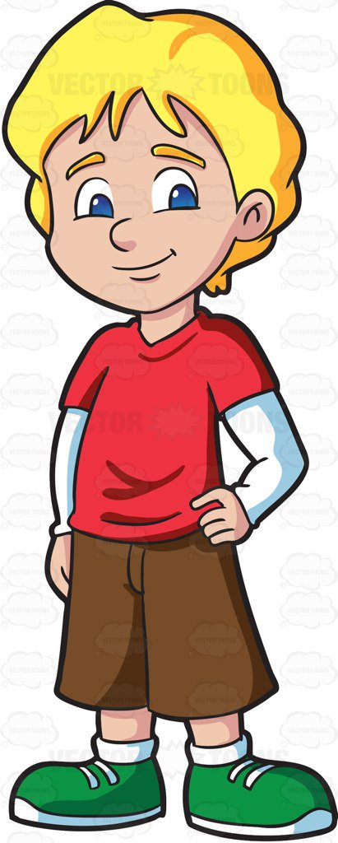

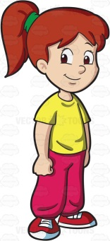

Hi! My Name is **Alex**, I’m seventeen years old and I live in Paris. We must listen to our teachers in our school and we must be polite. We mustn’t fight in the school and we mustn’t swear! We mustn’t be late in school and we mustn’t sleep in class! We mustn’t listen to music in the classroom or in the corridors, but we can listen to music in the playground.

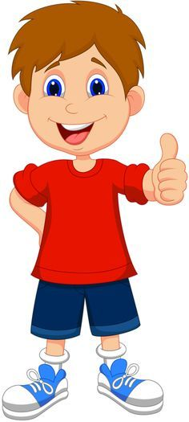

|  |  |  |
| --- | --- | --- |
| **Pupils** | **We must***…………* | **We mustn’t***…………* |
| Michael |  |  |
| Annie |  |  |
| Alex |  |  |

9.Read and correct the mistakes

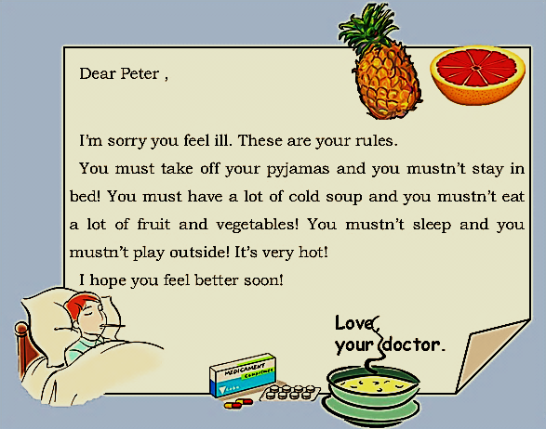

\_\_\_\_\_\_\_\_

\_\_\_\_\_\_\_\_

\_\_\_\_\_\_\_\_

\_\_\_\_\_\_\_\_

\_\_\_\_\_\_\_\_

\_\_\_\_\_\_\_\_

\_\_\_\_\_\_\_\_

10.Look ,choose and write with must or mustn’t .

|  |
| --- |
| drive fast (🗶) eat her salad (✓) go to the dentist (✓) run (🗶) take photo (🗶) wear a helmet(✓) |

|  |  |  |
| --- | --- | --- |
|  |  |  |
| He mustn’t run. |  | *………………………………………..* |
|  |  |  |
| *………………………………………..* | *………………………………………..* | *………………………………………..* |

11.Read and write

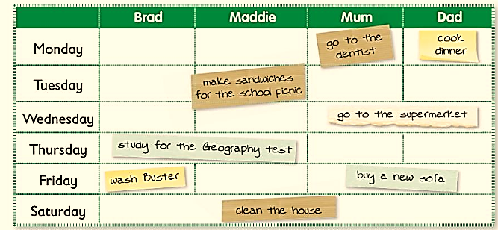

1. On Monday Mum **must go to the dentist.**
2. On Monday Dad *……………………………………………………………………..*
3. On Tuesday Maddie*…………………………………………………………………*
4. On Wednesday Mum and Dad*……………………………………………………*
5. On Thursday Brad and Maddie*……………………………………………………*
6. On Friday Brad*………………………………………………………………………*
7. On Friday Mum and Dad*…………………………………………………………*
8. On Saturday Brad , Maddie , Mum and Dad*…………………………………*

12.Write about the rules at school .Start your sentences with “ I must \_\_ “ or “I mustn’t \_\_

|  |  |
| --- | --- |
| 10132510-ilustracion-de-ninos-corriendo-en-una-pista-de-carreras[1] |  |
| I must wear sweat suit for my PE class. | ………………………………………………………………… |
| lazy studenrt | teamwork[1] |
| ………………………………………………………………… | ………………………………………………………………… |
| http://www.google.fr/url?source=imglanding&ct=img&q=http://www.kwayedza.co.zw/wp-content/uploads/2015/02/fighting-clipart-eiMrGr6in.gif&sa=X&ved=0CAkQ8wc4ImoVChMIt-6xppKDxgIVCgrbCh3yuwA7&usg=AFQjCNH_rZWe99KkCQosqsdLcfBTBaPaCg |  |
| ………………………………………………………………… | ………………………………………………………………… |
| large-No-Cell-Phones-Allowed-0-13970[1] | hands-up-color[1] |
| ………………………………………………………………… | ………………………………………………………………… |

**13. I must hoặc I mustn't \_\_\_\_\_ in the class.**

E.g. Listen to the teacher. 🡺 I must listen to the teacher.

1. say bad words. 🡺 \_\_\_\_\_\_\_\_\_\_\_\_\_\_\_\_\_\_\_\_\_\_\_\_\_\_\_\_\_\_\_\_\_\_\_\_\_\_\_\_\_

2. Do my homework. 🡺\_\_\_\_\_\_\_\_\_\_\_\_\_\_\_\_\_\_\_\_\_\_\_\_\_\_\_\_\_\_\_\_\_\_\_\_\_\_\_\_\_

3. Copy friends' papers. 🡺\_\_\_\_\_\_\_\_\_\_\_\_\_\_\_\_\_\_\_\_\_\_\_\_\_\_\_\_\_\_\_\_\_\_\_\_\_\_\_\_\_

4. Take notes in class. 🡺\_\_\_\_\_\_\_\_\_\_\_\_\_\_\_\_\_\_\_\_\_\_\_\_\_\_\_\_\_\_\_\_\_\_\_\_\_\_\_\_\_

5. Talk in class. 🡺\_\_\_\_\_\_\_\_\_\_\_\_\_\_\_\_\_\_\_\_\_\_\_\_\_\_\_\_\_\_\_\_\_\_\_\_\_\_\_\_\_

6. Fight with other students. 🡺\_\_\_\_\_\_\_\_\_\_\_\_\_\_\_\_\_\_\_\_\_\_\_\_\_\_\_\_\_\_\_\_\_\_\_\_\_\_\_\_\_

7. Go to school on time. 🡺\_\_\_\_\_\_\_\_\_\_\_\_\_\_\_\_\_\_\_\_\_\_\_\_\_\_\_\_\_\_\_\_\_\_\_\_\_\_\_\_\_  
**B. Hãy nhìn vào bảng hướng dẫn dành cho sinh viên trong trường. Sử dụng bảng này để đặt câu với “must” hoặc “mustn’t”.**

|  |  |
| --- | --- |
|  | must / mustn't |
| Attend all classes. |  |
| Take school books home with you. |  |
| Make a noise in the corridors. |  |
| Write in school books. |  |
| Arrive for lessons on time. |  |
| Bring your own pens and paper. |  |

**C. Write “must” hoặc “mustn’t” using words in the following table.**

|  |
| --- |
| study hard in the evening; run 15 minutes every morning; ~~dress neatly~~; watch television all day; ~~smoke~~; visit my grandfather; sleep in the afternoon; dance all night |

I mustn’t smoke.  
I must dress neatly.  
1.\_\_\_\_\_\_\_\_\_\_\_\_\_\_\_\_\_\_\_\_\_\_\_\_\_\_\_\_\_\_\_\_\_\_\_\_\_\_  
2. \_\_\_\_\_\_\_\_\_\_\_\_\_\_\_\_\_\_\_\_\_\_\_\_\_\_\_\_\_\_\_\_\_\_\_\_\_\_  
3.\_\_\_\_\_\_\_\_\_\_\_\_\_\_\_\_\_\_\_\_\_\_\_\_\_\_\_\_\_\_\_\_\_\_\_\_\_\_\_  
4. \_\_\_\_\_\_\_\_\_\_\_\_\_\_\_\_\_\_\_\_\_\_\_\_\_\_\_\_\_\_\_\_\_\_\_\_\_\_  
5.\_\_\_\_\_\_\_\_\_\_\_\_\_\_\_\_\_\_\_\_\_\_\_\_\_\_\_\_\_\_\_\_\_\_\_\_\_\_  
6\_\_\_\_\_\_\_\_\_\_\_\_\_\_\_\_\_\_\_\_\_\_\_\_\_\_\_\_\_\_\_\_\_\_\_\_\_\_

**D. Viết lại câu trong ngoặc đơn ( ) sử dụng “must” hoặc “mustn’t/must not”.**  
0.(Have some of this sweet cake. It's delicious.) You must have some of this sweet cake. It's delicious.  
1. (Don't play cards. It's bad.) You \_\_\_\_\_\_\_\_\_\_\_\_\_\_\_\_\_\_\_\_\_\_\_\_\_\_\_\_\_\_\_\_It's bad.  
2. (Passengers: Do not open the door while the bus is moving.)  
Passengers \_\_\_\_\_\_\_\_\_\_\_\_\_\_\_\_\_\_\_\_\_\_\_\_\_\_\_\_while the bus is moving.  
3. (Come for dinner with us one evening next week!)  
You\_\_\_\_\_\_\_\_\_\_\_\_\_\_\_\_\_\_\_\_\_\_\_\_\_\_\_\_\_\_one evening next week!  
4. (All staff: show identity cards when you enter the building.)  
All staff \_\_\_\_\_\_\_\_\_\_\_\_\_\_\_when they enter the building.