Unit 9 What’s the fastest animal in the world ?
1.Look and write the missing letters.

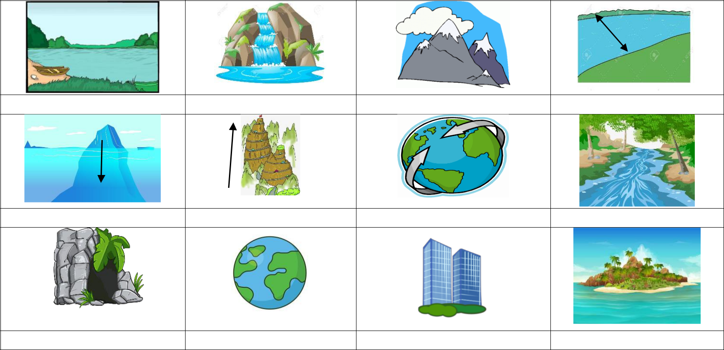

la _ _ | water _ _ll | mount _ _ _ | wi _ _

de _ _ | hi _ _ | oce _ _ | ri _ _ _

_
ca _ _ | w _ _ ld | b _ _ lding | isl _ _ _

2.Write sentences,using the comparative adjective of the word in brackets.

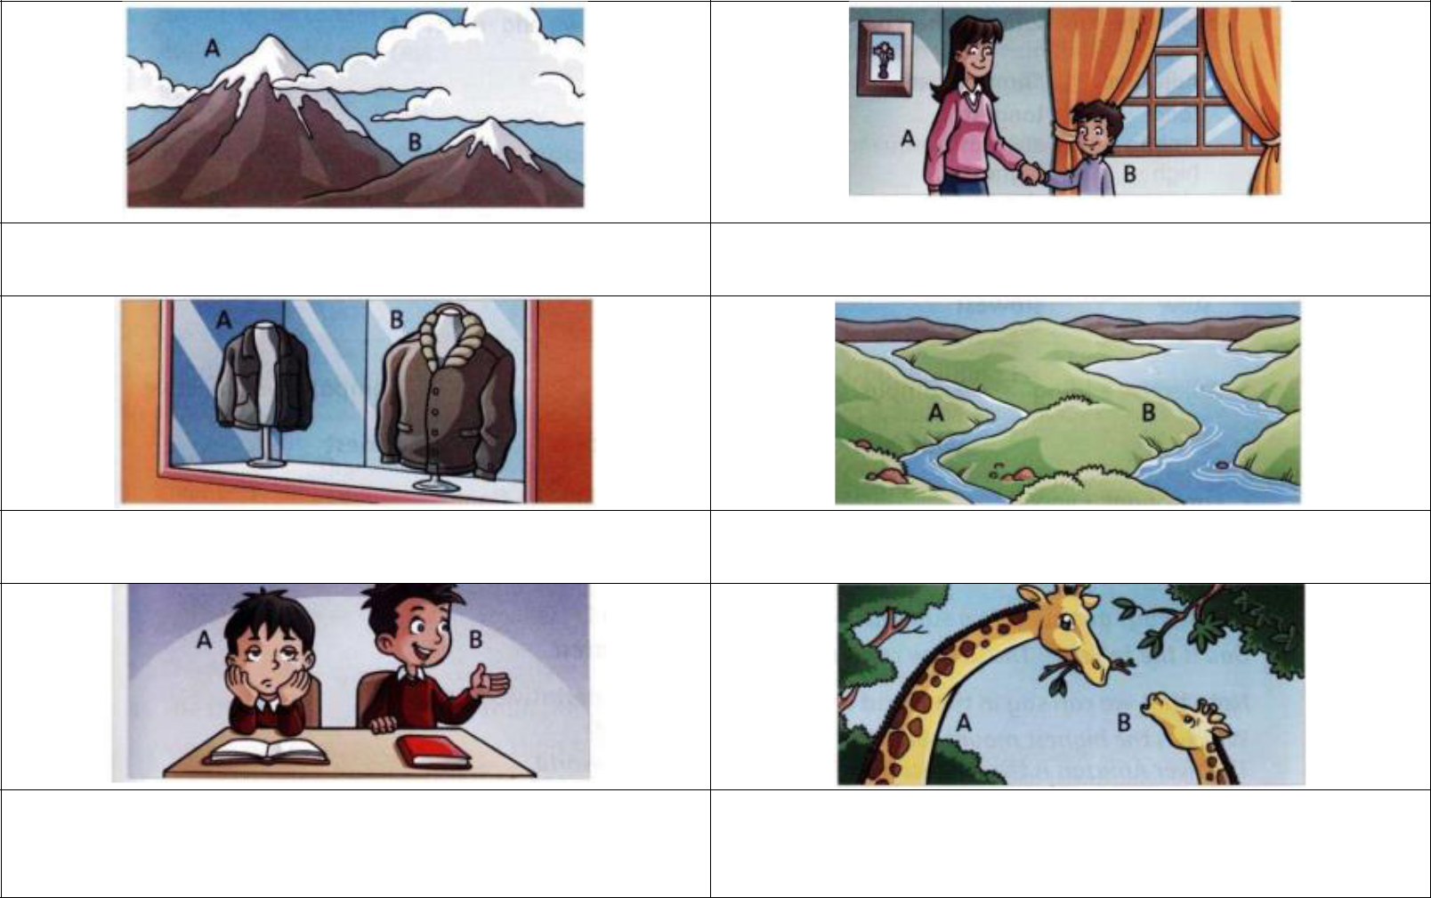

1. (high) A is higher than B | 2. (old) ………………………………………………..

3.(big) ……………………………………………….. 4. (wide) ………………………………………………..

5.(quiet)..................................................... | 6.(tall ) ………………………………………………..

3.Complete the sentences. Use the comparative form of the adjective in brackets.

- The River Nilde is longer than River Thames.(long )
- My sister is __________________ me . (old)
- Cars are _____________________ bikes.(fast )
- Cario is ______________________ London. (big)
- Summer is ______________________ Winter.(hot)
- Drinking water is______________________ drinking coke.(healthy)
- Egypt is ________________ Scotland.(hot )
- Argentina is _____________ Colombia.(big)
- The sun is ________________ the moon. (hot )
- Ben is _____________ his brother ( tall )
- Winter is ________________ summer (cold)
- Russia is ________________ Canada (big)
- The sun is ________________ the earth.(hot)
- The earth is ________________ the moon.( large )
- Lucy is _____________________ than Ellie.(old)
- A train is _________________ a plane. ( slow)
- A mouse is _____________________ a horse (short)
- A giraffe is _____________________ a horse ( tall )
- Viet Nam is _____________________ the U.S.A
- Cheetahs are ___________ elephants .(fast)
- This mountain is _________________ that mountain (tall )
- A rabbit is _____________________ a snail.(fast )
- Complete the sentences. Use the superlative form of the adjectives in brackets.

• December is the________ (cold) month  of the year in my country. | • Marie is the __________ (tall) girl in the  town.
• He is the ___________ (fast) boy in the  world. | • Bill is the ____________(nice) of the  class.
• June is the _________ (nice ) month of  the year. | • August is the __________ (hot) month  of the year.
• Our house is the _______ (big) in the  street. | • The Nile is _______ (long ) river in the  world.
• Everest is _______ (high) mountain in  the world. | • She is the ______ (smart )girl in the  class.
• I have three apples. This yellow apple  is the ______. (small ) | • The Missouri River is the ______  (long) river in the United States.
• Susie is the _______ (pretty ) of the four  girls. | • Summer is the __________ (hot) season  of the year.
• Asia is the _________ (big ) continent in  the world. | • The cheetah is the ________ (fast) land  animal in the world.
• She's the ________ (fast )runner in her  school. | • Grapefruit is the ________ (healthy)  fruit.
• He is __________________(rich) guy in  school. | • London is the __________ (big) city in  the UK.

5.Read the text .Choose the correct words.

 | already | oldest bigger | in more | of rarely | yet
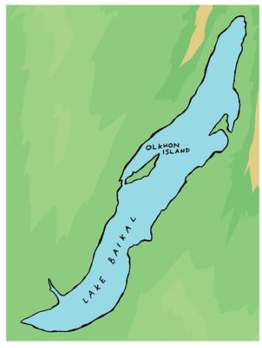 |  |  | Lake Baikal | and Olkhon | Island
 |  |  | Lake Baikal | in Russia is the oldest lake in the
 |  |  | world. It is also the world’s __________
 |  |  | Lake .With an area òf 730 km2
 |  |  | , Olkhon island is _______________ than any
 |  |  | other island ___________ Lake Baikal.
 |  |  | It’s a beatiful place and it _____________ rains
 |  |  | there.________ people on Olkhon are fisherman
 |  |  | or farmers. But these days tourism is becoming
 |  |  | a ___________ important part _____________ the
 |  |  | economy on Olkhon and all around the lake .A
 |  |  | tourist organisation calles the Great Baikal Trail
 |  |  | is building a 1,800 km footpath around the lake
 |  |  | .They haven’t finished the path ______________,
 |  |  | but walkers can ______________ use some parts
 |  |  | of it.

6.Look ,read and answer.

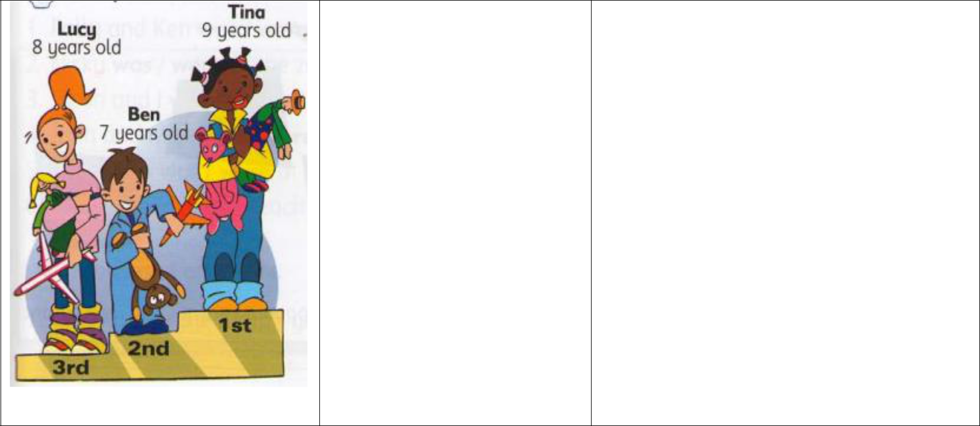
Who’s the shortest ? Ben is the shortest boy of the three.

Who’s the oldest ? ...........................................................

Who’s the best ? .............................................................

Who’s the worst ? .............................................................

Who’s the youngest ? .............................................................

Who’s got the longest ...........................................................

hair ?

7.Circle the correct words.

- It is the uglier/ ugliest house in the street.

- Jane is taller /tallest than Helen.

- The blue dress is nicest/nicer than the red dress.

- London is biggest/bigger than Manchester.

- This is the taller/tallest tree in my garden.

- A lion is fastest/faster than a cat.

- Zoe has the heaviest /heavier bag in the class.

- That is the cheaper / cheapest doll in the shop.

- The clown is funnier /funniest than that clown.

- August is the hotter /hottest month of the year.

- January is the colder/coldest month of the year.

- This is the bigger/biggest park in my town.

- This is the smaller/smallest toy shop in my town.

- An elephant is bigger/biggest than a mouse.

- The Pacific Ocean is the larger/largest ocean in the world.

- Colombia is the wetter/wettest country in the world.

- The Burj Khalifa in Dubai is the taller/tallest building in the world.

- The Sahara Desert is the bigger/biggest desert in the world.

8.Put the words in the correct order to make sentences

tortoise /is/My/slower/my/than/rabbit./ | Jane’s /hair/the/is /longest/in/class./the
…………………………………………………………… | ……………………………………………………
whale/The /is/the /biggest /all/of /the | The/baby/the/is/youngest/the/in/family./
/animals./
…………………………………………………………… | …………………………………………………………
Anna/the/is/youngest/the/in/company/ | class./in/the/Sue/is/the /happiest/child/
…………………………………………………………… | …………………………………………………………
family./in/the/Lucy/is/the /happiest/child/ | Jane’s /hair/the/is /longest/in/class./the
…………………………………………………………… | …………………………………………………………
That/is/giraffe/the/tallest /in /the | Jane’s /hair/the/is /longest/in/class./the
/zoo./animal/
…………………………………………………………… | …………………………………………………………
Amazon/is /the/longest/the/river/South/ | She’s/player/the/tallest/the/in/team./
in/America./
…………………………………………………………… | …………………………………………………………
grandma/My/the/is/oldest/person/in/my/ | Russia/the/is/biggest/in/country/the/
family. | world./
…………………………………………………………… | …………………………………………………………
A giraffe /taller/is/than/ a /camel./ | Paul /is the/ boy/ tallest/ in/ the
 | neighborhood.
…………………………………………………………… | …………………………………………………………
January / the /is/coldest of/month /the /year. | yellow/The/car/is/the /fastest./
…………………………………………………………… | …………………………………………………………
Fansipan/highest/is/the/mountain/in/ Viet | The Dong Nai/river/the/is/longest/river
Nam. | /in/Viet Nam.
…………………………………………………………… | ………………………………………………………

9.Read , match and circle the correct word.

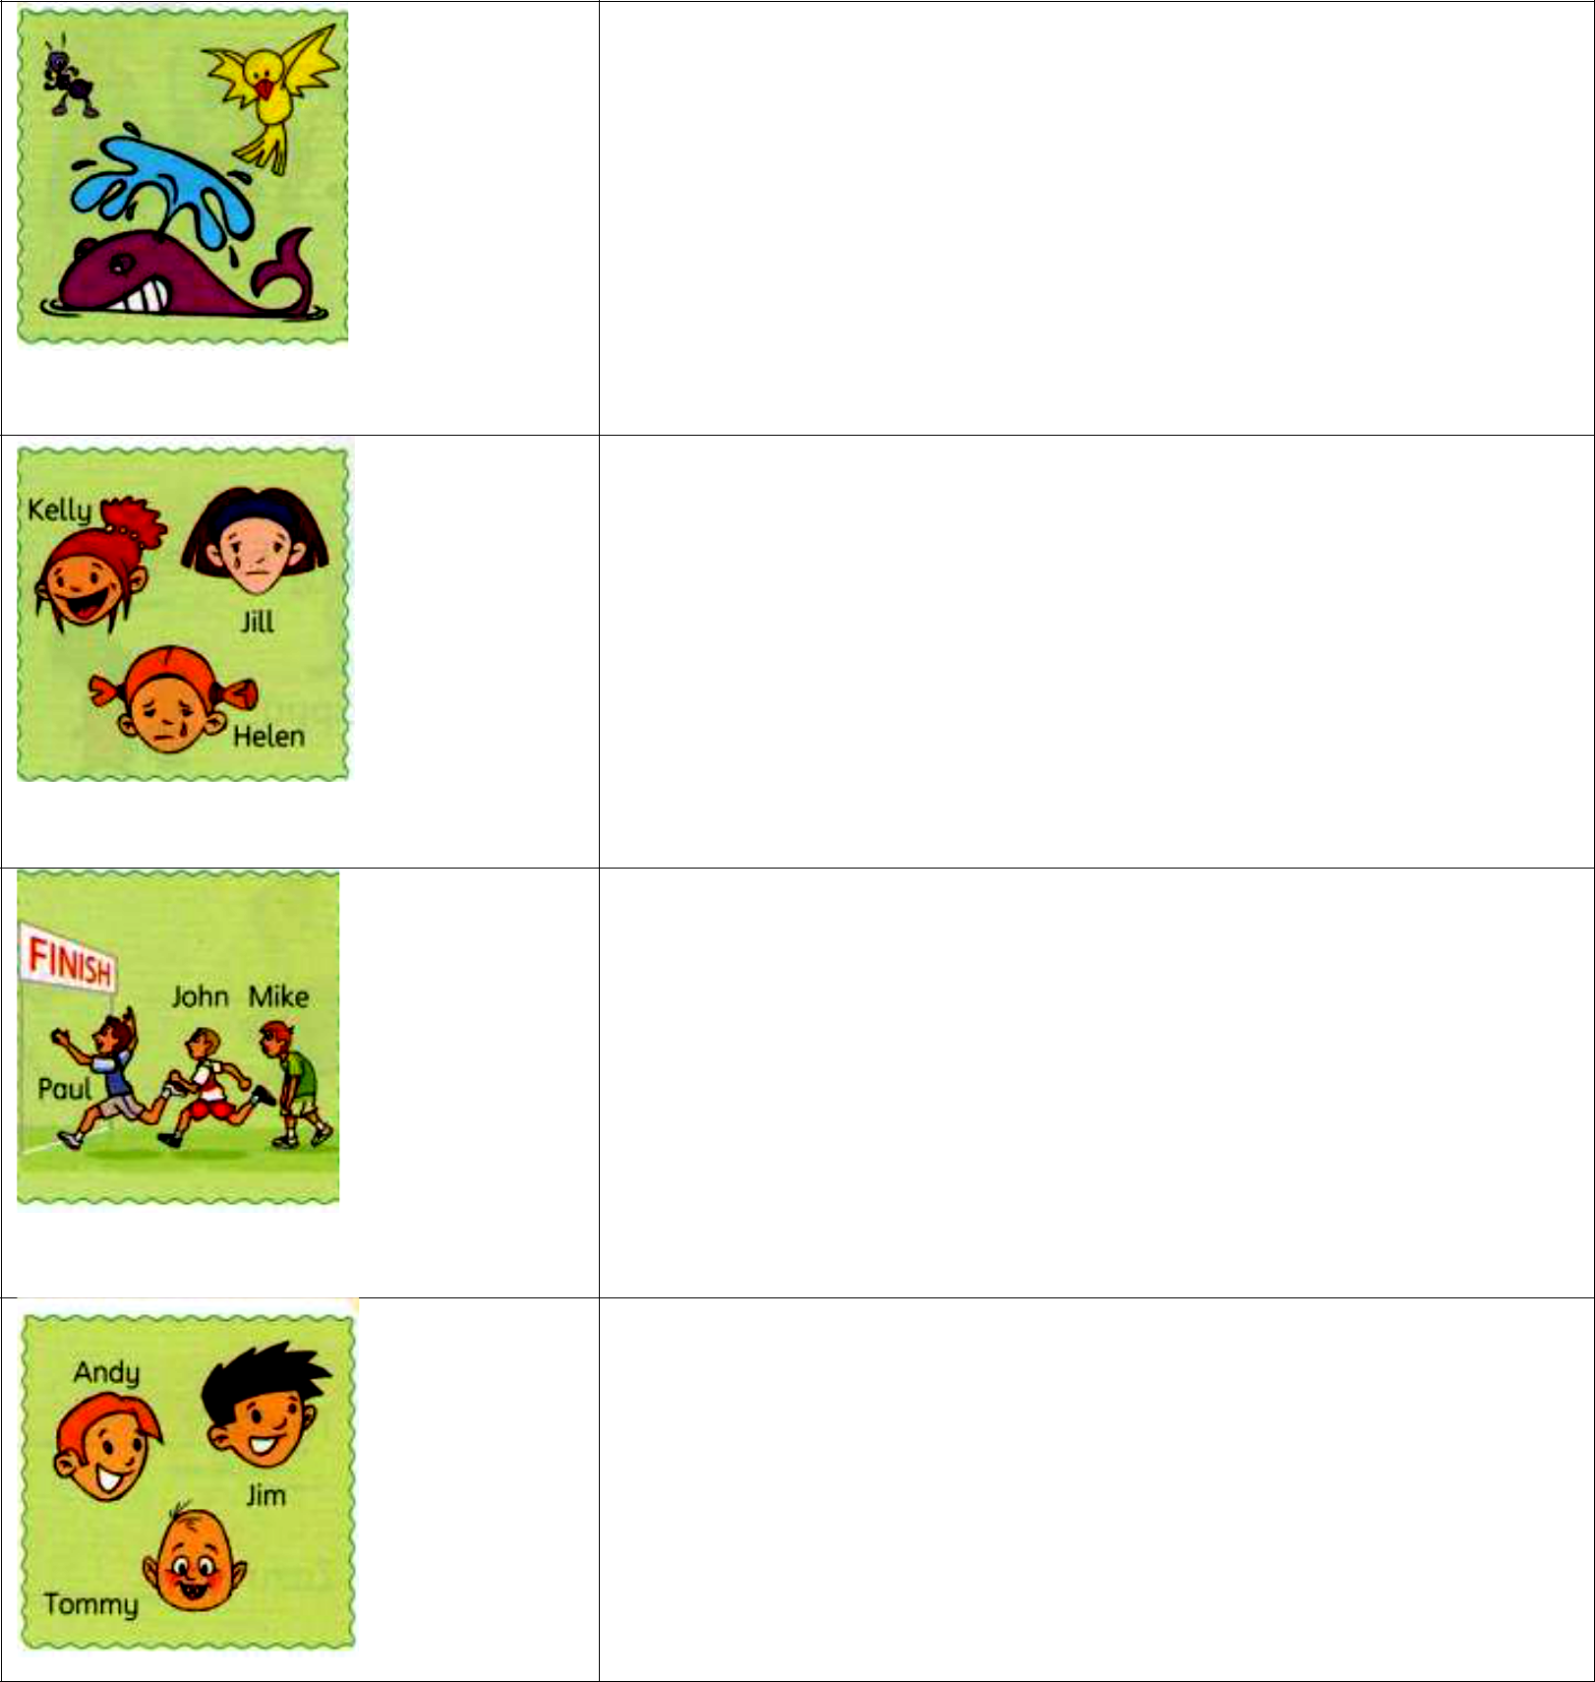

Kelly is the happier /happiest girl of the three.

Paul is the better/best runner of the three.

Tommy is the younger/ youngest boy of the three.

The whale is the bigger/biggest animal of the three.

10.Find the mistakes and correct them.

The sun is the |  | hotter | than any other |  |  |  | Toby is tallest than Luke
planets.
The sun is hotter than any other planets. |  |  |  |  |  |  | …………………………………………………
My brother is laziest |  |  |  | than me! |  |  | The cheetah is the faster mammal in the
 |  |  |  |  |  |  | world.
………………………………………………… |  |  |  |  |  |  | …………………………………………………
I am sure the Nile is the longer river in the |  |  |  |  |  |  | London is big than Paris
world.
………………………………………………… |  |  |  |  |  |  | …………………………………………………
London is the bigger city in England. |  |  |  |  |  |  | Toby are the tallest boy in the class.
………………………………………………… |  |  |  |  |  |  | …………………………………………………
My neighbor are nicer than the people |  |  |  |  |  |  | The earth is largest than the moon.
living opposite.
………………………………………………… |  |  |  |  |  |  | …………………………………………………
 | 11. Odd one out
 | a. wide |  |  |  | b. deep |  | c. high |  | d. cave
 | a. school |  |  |  | b. lake |  | c. rive |  | d. waterfall
 | a. Japan |  |  |  | b. Korea |  | c. England |  | d. American
 | a. water |  |  |  | b. bottle |  | c. | pencil | d. shop
 | a. chocolate |  |  |  | b. cheese |  | c. | waiter | d. oranges
 | a. seventy |  |  |  | b. swimming |  | c. | skiing | d. football
 | a. beer |  |  |  | b. tea |  | c. | oranges | d. wine
 | a. book |  |  |  | b. television |  | c. | pen | d. eraser
 | a. Theatre |  |  |  | b. classroom |  | c. | ticket | d. movie
 | a. lunch |  |  |  | b. dinner |  | c. | photo | d. breakfast
 | a. hen |  |  |  | b. plate |  | c. | bowl | d. | Ocean
 | a. spoon |  |  |  | b. sharpener |  | c. | pen | d. apple
 | a. salt |  |  |  | b. teacher |  | c. | sweet | d. sour

- Compare the following people:
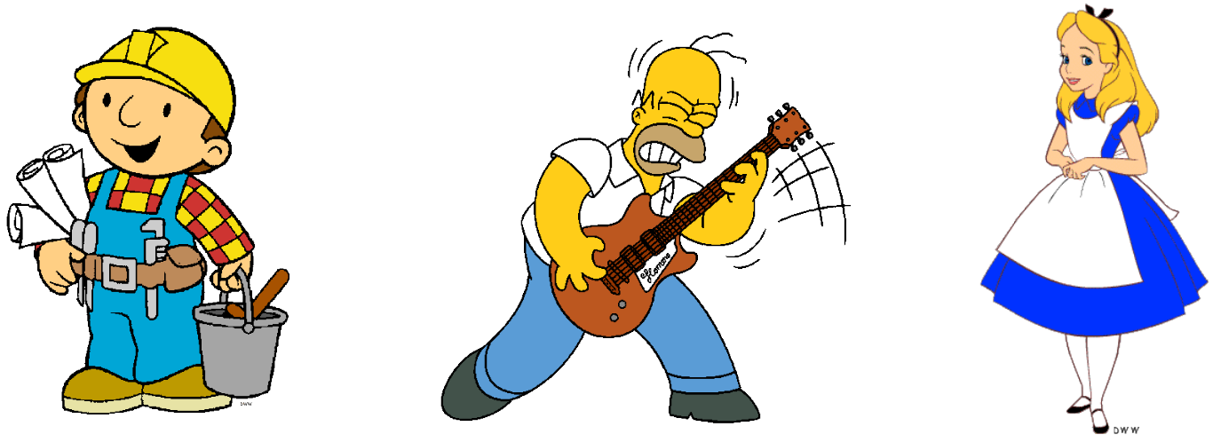

Bob | Homer | Alice
28 years old | 39 years old | 9 years old
55 kilos | 80 kilos | 33 kilos
1.50 mt | 1.55 mt | 1.20 mt.
- Bob is ___________ (young) than Homer.
- Homer is _____________ (old) than Alice.
- Alice is ______________(slim ) than Bob.
- Bob is ______________ (short) than Homer.
- Homer is _____________ (fat) than Bob.
- Alice is_______________ (short) than Homer
- Homer is _____________ (ugly)than Alice.
- Homer is _____________ (slow) than Bob.
- Alice has _____________(long) hair than Bob.
10.Alice can run ______________ (fast ) than Homer.

13.Compare the animals. Write the sentences with than

⇨ mouse | cat | (big ) | bear | dog | (heavy )
 |  |  | ……………………………………………………
A cat is bigger than a mouse .
monkey | gorilla | (strong) | snail | cat | (fast )
…………………………………………………… |  |  | ……………………………………………………
whale | fish (long ) |  | snake | crocodile | (thin)
…………………………………………………… |  |  | ……………………………………………………
rabbit | tortoise (fast) |  | giraffe | camel (tall)
…………………………………………………… |  |  | ……………………………………………………

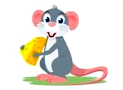

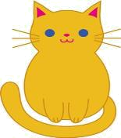

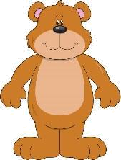

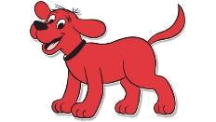



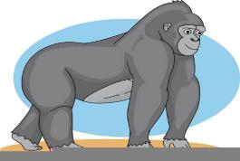



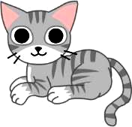

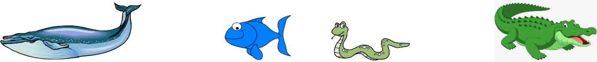

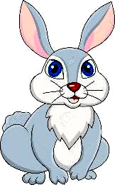

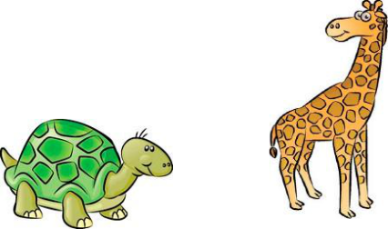

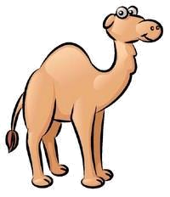

14.Write
snake giraffe cheetah tortoise donkey dolphin

- The dolphin is the most intelligent animal in the world.
- ________________ is the fastest animal in the world.
- ________________ is the slowest animal in the world.
- _______________ is the most dangerous animal in the world.
- ________________ is the most useful animal in the world.
- ________________ is the tallest animal in the world.
15.Read and match
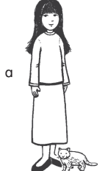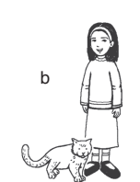

- In this picture , the girl is smaller . Her hair is shorter . She looks happier than the girl in the other picture . In this picture ,that cat is bigger and it has a longer tail . __________________
- In this picture , the girl is taller . Her hair is longer . The cat is smaller and it has a short tail. __________________
16. Odd one out
1 | - get up | - get dressed | - walk to school | - together
2 | - toy | - soil | - boy | - coin
3 | - first | - them | - then | - finally
4 | - library | - museum | - ticket | - swimming pool
5 | - cheese | - potato | - pepper | - sugar
6 | - shield | - belt | - quilt | - child
7 | - mountain | - fountain | - animal | - waterfall
8 | - sand | - cheetah | - plant | - camp
9 | - path | - bin | - park | - playgrpound
10 | - shout | - chase | - catch | - loud

