1.Look and write

|  |  |  |  |
| --- | --- | --- | --- |
| cucumber onion lemon melon meat cereal  noodles mushrooms pastry garlic bean sprouts sauce | | | |
|  | | HÃ¬nh áº£nh cÃ³ liÃªn quan | Káº¿t quáº£ hÃ¬nh áº£nh cho cereal clipart | Káº¿t quáº£ hÃ¬nh áº£nh cho mushroom clipart | |
| *……………………….* | | *……………………….* | *……………………….* | *……………………….* | |
| HÃ¬nh áº£nh cÃ³ liÃªn quan | | Káº¿t quáº£ hÃ¬nh áº£nh cho onion clipart | Káº¿t quáº£ hÃ¬nh áº£nh cho melon  clipart | Káº¿t quáº£ hÃ¬nh áº£nh cho lemon  clipart | |
| *……………………….* | | *……………………….* | *……………………….* | *……………………….* | |
| Káº¿t quáº£ hÃ¬nh áº£nh cho garlicclipart | | Káº¿t quáº£ hÃ¬nh áº£nh cho bean sprout clipart | Káº¿t quáº£ hÃ¬nh áº£nh cho meat  clipart | Káº¿t quáº£ hÃ¬nh áº£nh cho pastry cartoon | |
| *……………………….* | | *……………………….* | *……………………….* | *……………………….* | |

2. Put the words in the correct column

bean sprouts mushrooms egg milk tomato fruit bread juice tea chocolate

cereal apple lemon meat rice potato carrot grapes oil cucumber

sugar onion coffee tea cheese garlic plum water orange melon

|  |  |
| --- | --- |
| **Countable** | **Uncountable** |
| *…………………………………………………..*  *…………………………………………………..*  *…………………………………………………..*  *…………………………………………………..* | *…………………………………………………..*  *…………………………………………………..*  *…………………………………………………..*  *…………………………………………………..* |

3. Look, write the food words with **a , an** or **some.**

tomatoes salad cake cheese strawberries crisps

pineapple lemonade sugar carrots mango juice egg

|  |  |
| --- | --- |
| Sue has some tomatoes, some salad, a cake *…………………………………………………………………….*  *……………………………………….……………………………………….……………………………………….............................* |  |

4.Look at the picture and complete the text with words form the box.

carrot lemon pineapple fruit juice apple milk

|  |  |
| --- | --- |
|  | They have two c**arrots** but they don’t have an _______________.They have ____________ but they don’t have ____________.They have a _________ and three ________________. |

5.Look at the picture .Write **There’s a There’s some** or **There are some**

|  |  |
| --- | --- |
|  | ⇨There’s a table.  _____________________cheese.  _____________________butter.  _____________________ grapes.  _____________________ bread.  _____________________ biscuits  _____________________ cake..  _____________________ pear.  _____________________ plates.  _____________________ bottle. |

6.Comple the sentences with the words from the box.

a some please ~~like~~ Would No

|  |  |
| --- | --- |
| Dad : Would you like a sandwich , Sally ?  Sally : Yes, ____________ .  Dad : ___________ you like ___________cheese in your sandwich?  Sally : _________, thank you . I’d like a sausage.  Dad : Would you like an apple or _____________ banana , too ?  Sally : Yes, please - a banana. |  |

7.Look and write answer.

|  |  |  |  |
| --- | --- | --- | --- |
| Káº¿t quáº£ hÃ¬nh áº£nh cho cereal clipart | http://images.clipartpanda.com/smiley-face-clipart-black-and-white-Happy.jpg | Would you like some cereal ? | Yes , please. |
|  | http://images.clipartpanda.com/sad-face-clipart-black-and-white-opc5KxjTB.png | Would you like a pineapple ? | *……………………………….* |
| Káº¿t quáº£ hÃ¬nh áº£nh cho grapes clipart | http://images.clipartpanda.com/smiley-face-clipart-black-and-white-Happy.jpg | Would you like some grapes ? | *……………………………….* |
| Káº¿t quáº£ hÃ¬nh áº£nh cho orange  clipart | http://images.clipartpanda.com/sad-face-clipart-black-and-white-opc5KxjTB.png | Would you like an orange ? | *……………………………….* |
| HÃ¬nh áº£nh cÃ³ liÃªn quan | http://images.clipartpanda.com/smiley-face-clipart-black-and-white-Happy.jpg | Would you like some fruits ? | *……………………………….* |
| HÃ¬nh áº£nh cÃ³ liÃªn quan | http://images.clipartpanda.com/smiley-face-clipart-black-and-white-Happy.jpg | Would you like an ice cream ? | *……………………………….* |
| Káº¿t quáº£ hÃ¬nh áº£nh cho some apples  clipart | http://images.clipartpanda.com/sad-face-clipart-black-and-white-opc5KxjTB.png | Would you like some apples ? | *……………………………….* |
| HÃ¬nh áº£nh cÃ³ liÃªn quan | http://images.clipartpanda.com/sad-face-clipart-black-and-white-opc5KxjTB.png | Would you like some lemonade ? | *……………………………….* |
| Káº¿t quáº£ hÃ¬nh áº£nh cho juice clipart | http://images.clipartpanda.com/smiley-face-clipart-black-and-white-Happy.jpg | Would you like some juice ? | *……………………………….* |
| Káº¿t quáº£ hÃ¬nh áº£nh cho milk clipart | http://images.clipartpanda.com/smiley-face-clipart-black-and-white-Happy.jpg | Would you like some milk ? | *……………………………….* |

8. Write **a, an** or **some.**

|  |  |  |  |
| --- | --- | --- | --- |
| Káº¿t quáº£ hÃ¬nh áº£nh cho fish food clipart | Would you like _______ fish ? | Káº¿t quáº£ hÃ¬nh áº£nh cho rice  clipart | Would you like ______ rice? |
| Káº¿t quáº£ hÃ¬nh áº£nh cho noodle clipART | Would you like _______ noodles? | Káº¿t quáº£ hÃ¬nh áº£nh cho salad clipart | Would you like _______ salad? |
| Káº¿t quáº£ hÃ¬nh áº£nh cho CHicken food clipart | Would you like _______ chicken? |  | Would you like _______ milk ? |
| Káº¿t quáº£ hÃ¬nh áº£nh cho orange  clipart | Would you like _______ orange ? | Káº¿t quáº£ hÃ¬nh áº£nh cho bread clipart | Would you like _______ bread ? |
| Káº¿t quáº£ hÃ¬nh áº£nh cho apple food clipart | Would you like _______ apple ? |  | Would you like _____ pineapple? |

9.Look,read and tick (✓) or cross (🗶)

1. 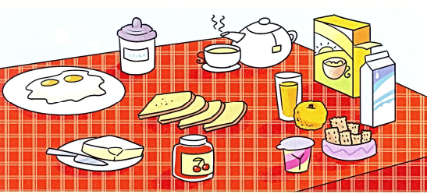The yogurt is next to the butter.
2. The tea is next to the eggs.
3. The cereal is opposite the orange juice.
4. The cereal is next to the milk.
5. The biscuits are opposite the yogurt.
6. The sugar is next to the jam
7. The toast is between the sugar and the jam

9.Write in order .Complete the answers.

a. you/sandwich?/like/Would /a

**Would you like a sandwich** ? **Yes** , please.

b. like/some/grapes? /Would/you/?/

________________________________________ Yes, _______________.

c. drink ?/ you/Would /a /like /

________________________________________ _______________,thanks.

d. you /biscuits? /some /like /Would

________________________________________ Yes, _______________.

e. a/Would /like/you/cupcake ?/

________________________________________ No,_______________.

f. some/you/Would/like/strawberries /

________________________________________ No,_______________.

g. you /chips? /some /like /Would

________________________________________ Yes, _______________.

h. a/Would /like/you/pear ?/

________________________________________ No,_______________.

i. some/you/Would/like/cherries? /

________________________________________ No,_______________.

h. a/Would /like/you/pizza?/

________________________________________ Yes, _______________.

10.Look and circle

|  |  |
| --- | --- |
|  | 1. There’s some **cola /juice** in the jug. 2. There’s some **fruit /meat** on the plate. 3. There’s some **milk /jam** in the fridge. 4. There’s some **meat /fish** in the fridge. 5. There’s some **cola /coffee** in the fridge. |

11.Look,read and write **yes** or **no**

|  |  |  |
| --- | --- | --- |
|  | * She’d like some rice. * She’d like some meat. * She’d like some vegetables. * She’d like a cucumber. * She’d like some noodles. * She’d like some fish. * She’d like some water. * She’d like some bread. * She’d like an onion. * She’d like some cereal. * She’d like some orange juice. | No  *………*  *………*  *………*  *………*  *………*  *………*  *………*  *………*  *………*  *………* |

11. Complete the sentences.

1. _________ you like apples ? Yes , I do.
2. _________ she like tea ? No , she doesn’t.
3. I would like ________ tea , please.
4. Would you like ________ apple ? Yes , please.
5. ________ you like an orange ? No , thanks.
6. Would you like _______biscuit ? Yes , please.
7. _________ they like bananas ? Yes ,they do.
8. Would you like _______water ? No , thanks .
9. What would you like to drink ? I _______ like some milk.
10. What would you like to drink ? I would like _______ orange juice.
11. What ________ you like to drink ? I would like a hamburger.
12. Would you like some bread ? Yes , _________________ .
13. Would you _______ some orange juice ? __________,thanks.
14. ____________ he like some cereal ? Yes, he does.
15. I’m hungry . I’d like __________ sandwich.
16. I’m thirty . I’d like _________ water.
17. _______ you eat meat ? Yes , I can.
18. _________ Anna like noodles ? Yes , she does.
19. Would you like ________ cereal ? Yes , please.
20. Would you like ________ coffee ?No, thanks.
21. Would you like some lemons ? Yes , _________________ .

12.These are Mary and Tom’s food likes and dislikes.Write 6 sentences using “like /doesn’t like.

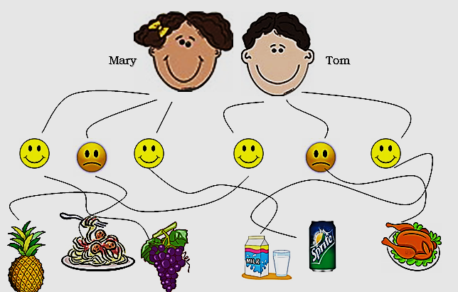

Pineapple Spaghetti Grapes Milk Sprite Chicken

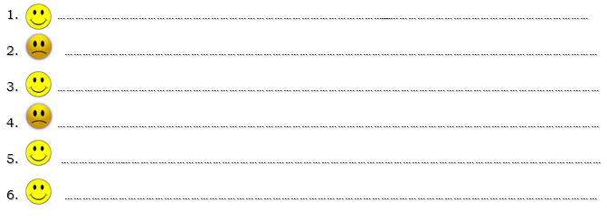13.Match

|  |  |  |
| --- | --- | --- |
| 1. What would you like to eat ? | 1. I’d like some milk. |  |
| 1. Would you like some orange juice? | 1. I’d like a sandwich. |  |
| 1. What would you like to drink ? | 1. No, thanks. |  |
| 1. What is your favorite food ? | 1. My favorite drink is chocolate milk   It is so delicious when it is very cold. |  |
| 1. What is your favorite drink ? | 1. My favorite food is pizza. I love it because it is so tasty. |  |
| 1. Do you like milk ? | 1. No, she doesn’t |  |
| 1. Do she like lemonade ? | 1. Yes , I do. |  |

14. Odd one out

|  |  |  |  |
| --- | --- | --- | --- |
| 1. chicken | 1. pork | 1. beef | 1. lemonde |
| 1. kiwi | 1. grapes | 1. milk | 1. apple |
| 1. milk | 1. meat | 1. lemonade | 1. orange juce |
| 1. hate | 1. like | 1. love | 1. enjoy |
| 1. breakfast | 1. lunch | 1. dinner | 1. cucumber |
| 1. rose | 1. daisy | 1. lily | 1. hungry |
| 1. cereal | 1. noodles | 1. rice | 1. water |
| 1. a | 1. an | 1. some | 1. eat |
| 1. eat | 1. drink | 1. cook | 1. strong |
| 1. skirt | 1. dress | 1. rubber | 1. jacket |
| 1. jump | 1. call | 1. cook | 1. blue |
| 1. throw | 1. sharpener | 1. pen | 1. apple |
| 1. talk | 1. tall | 1. throw | 1. think |

**15. Choose the correct answers**

1. Minh often …………….. at 7 o’clock then he ………….. and has breakfast at quarter past seven.
2. Get up/gets dressed C. gets up/gets dressed
3. Get/ gets dressed D. got up/gets dressed
4. My grandparents ……………….a lot of cookies.
5. have B. don’t have C. has D. doesn’t have
6. Lan never …………… to school on Saturday.
7. go B. walk to C. come D. goes
8. Linh’s birthday is ……….. March.
9. on B. in C. at D. with
10. …………….you like some water?
11. Would B. Are C. Is D. Was
12. I’d like …………. apple and …………….bread.
13. An/ a B. a/a C. some/some D. an/ some

**16. Underline and correct mistakes**

1. She don’t live in Australia.

………………………………………………………………………………………

1. Linh always eat bread for her breakfast.

………………………………………………………………………………………

1. Would you like some banana?

………………………………………………………………………………………

1. I’d likes some bread and butter.

………………………………………………………………………………………