1.Look , read and write
cafe’ library museum shopping mall swimming pool playground
 |  | 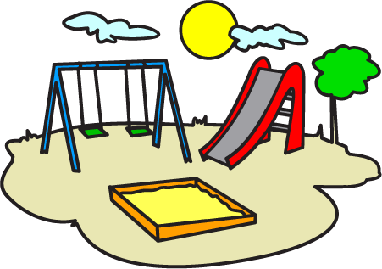
………………………………… | ………………………………… | …………………………………
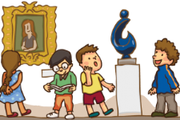
……………………………………… | ……………………………… | …………………………………
2. Look and circle the correct words
- We always go /goes to the playground on Saturday. | - She sometimes go/goes to the library.
- My brother never goes/go to the shopping mall | - Anna never rides/ride her bike on the weekend.
- My sister always take/takes photos. | - The children always go/goes to bed at nine o’clock.
- My friends always fly/flies the kites on Sunday. | - I sometimes watch/watches TV
- My father always go/goes to the café’ every morning. | - My family always go/goes to the movie theater on Saturday.
- What do you always eat/eats for breakfast ? | - Jane sometimes go/goes to school by bus.
- Toby always goes /go to the café’ before work. | - Peter never go/goes to the library.
- We never eats/eat ice cream after dinner. | - We sometimes go/goes to the swimming pool on Sundays.
3.Write sentences.Put the adverb in the correct position.
a. We go to the cinema.(sometime)
We sometimes go to the cinema.
b. Anna gets up early every morning.(always)
………………………………………………………………………….
3. Lisa helps her parents with the housework (sometimes)
………………………………………………………………………….
4. We are late to school (never)
………………………………………………………………………….
5. Laura has breakfast with her family(always)
………………………………………………………………………….
6. David doesn't study the grammar reference before his tests (never)
………………………………………………………………………….
7. My sister goes to bed late (always)
………………………………………………………………………….
8.My mother eats in the restaurant.( sometimes)
………………………………………………………………………….
9.They read books in the library on Sunday . (always)
………………………………………………………………………….
10. We go to the swimming pool on Sunday. (sometimes)
………………………………………………………………………….
11. Ann surfs the Net in the evening. (always)
………………………………………………………………………….
12. I go swimming on Sunday. (sometimes)
………………………………………………………………………….
13. Sam goes out with his friends. (sometimes)
………………………………………………………………………….
14. Ted reads magazines about fashion. (always)
…………………………………………………………………………
4. Read and write
 | Yes, I do. | Yes, she does. |  | Yes, he does. | Yes,they do.
 | No, I don’t. | No, she doesn’t. |  | No,he doesn’t. | No, they don’t.
Do you go to the museum on the weekend ? () |  |  | Do you usually go shopping? ()
……………………………………. |  |  | …………………………………….
Does he ever go to the sports center?() |  |  | Does your father go to the café every morning?()
……………………………………. |  |  | …………………………………….
Do you sometimes go to the movie theater ? () |  |  | Does he play basketball every day ? ()
……………………………………. |  |  | …………………………………….
Do they walk to school every day? () |  |  | Does she go to bed late ? ()
……………………………………. |  |  | …………………………………….
Does your sister get up early every morning ? () |  |  | Do you watch television in the evening. ?
……………………………………. |  |  | …………………………………….
5.Circle the correct option .
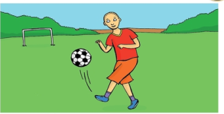 | 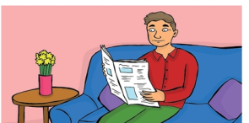
John loves/is loving sport . He plays/is playing basketball and he plays/ is playing football .Right now he plays/is playing football. | My dad is a teacher .He teaches /is teaching sicence. Today’s Saturday .He doesn’t teach /isn’t teaching now – He reads/is reading the newspaper.
5.Read the texts and complete the sentences .Choose from the box.
reads is reading walks is walking
work isn’t working teaches aren’t teaching
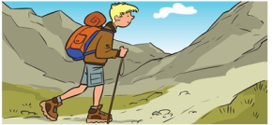 |  | 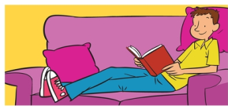 | 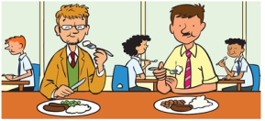
Ben is a student .He reads a lot of books.  Today he’s on holiday . He ______________ in the mountains. |  | Joe is a postman.Every day he ______ round the town delivering letters.He _________ now . He  ___________ a book . | Did and Dan _________ in a school. Sid ____________ Frend and Dan’s subjects is maths . They __________ now .They’re having lunch.
6 Fill in : in , at , on
On Monday | …………….. 6:15
…………….. the morning. | …………….. the afternoon
…………….. 8:30 | …………….. Thursday
…………….. the evening | …………….. night
…………….. Friday | …………….. 9:45
…………. the summer | ………….. Monday morning
…………. the weekend | ……………. the winter
7. Look at table and write.
= always = sometimes = never
 | go to the playground | go to the library | go to the swimming pool | go to the shopping mall | go to the museum
Lisa
Toby
Elsa
Ben

- Lisa always goes to the play ground. | - Toby _________ goes to the swimming pool
- Elsa ________ goes to the library. | - Ben __________ goes to the shopping mall
- Lisa _________ goes to the museum. | - Toby _________ goes to the play ground.
- Ben ________ goes to the library. | - Toby ________ goes to the library.
- Lisa _________ goes to the swimming pool | - Elsa _________ goes to the swimming pool
8.Write the words.
Marry : Tell me about your day .What _________ do you get up ?
Hugo : Ok .Well , I always get up __________ seven o’clock.
Marry : _______________ do you go to school ?
Hugo : At nine ____________________.
Marry : And when __________ you play in the park ?
Hugo : On Saturday at ___________ o’clock.
9.Read and answer
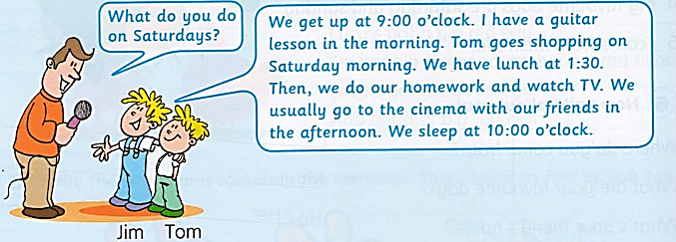
- Do Jim and Tom get up at 9 :00 o’clock ?....................................................
- Does Jim make a cake in the morning ? ................................................
- Does Tom go shopping in the morning? ................................................
- Do Jim and Tom have lunch at 2 :00 o’clock ? ........................................
- Do Jim and Tom go to the cinema with their mother ? .......................................................
- Do Jim and Tom sleep at 10 :00 o’clock ? ...........................................................
10.Put the words in the correct order to make sentences
a. sometimes/reads/He/in/the/afternoon./books/
………………………………………………………………………………….
b. play/They/always/tennis/ on/ Saturday./
………………………………………………………………………………….
c. swims/always/My/sister/in/summer./the
………………………………………………………………………………….
d. never/goes/She/shopping/Monday./on/
………………………………………………………………………………….
e. drives/sometimes/car/He/his/work./to/
………………………………………………………………………………….
f. My/sister/her/homework/does/in/the afternoon./
………………………………………………………………………………….
g. have/a/shower/I /early/in/morning./the
………………………………………………………………………………….
h. basketball/My/brother/always/plays/Sunday.//on/
………………………………………………………………………………….
i. never/My/father/go/shopping./
………………………………………………………………………………….
j. get/up/early/I /always/the/morning./in/
………………………………………………………………………………….
k. theater/sometimes/She/movie/goes/to/the/Sunday./on
………………………………………………………………………………….
l. My/always/friends/ football/play/on Saturday afternoons./
………………………………………………………………………………….
m. always/go/to/the/beach/on/the/weekend./We
………………………………………………………………………………….
n. never/We/go/to/the/mountains …………………………………………………………….
11. Odd one out
- black | - grey | - pink | - eraser
- museum | - hospital | - school | - balcony
- bedroom | - kitchen | - carpet | - dining room
- spoon | - cow | - fork | - knife
- football | - tennis | - basketball | - water
- rose | - daisy | - lily | - computer
- swimming | - cycling | - face | - climbing
- bus | - bike | - car | - taxi
- bus | - thirty | - plane | - train
- skirt | - dress | - rubber | - jacket
- jump | - call | - cook | - blue
- throw | - sharpener | - pen | - apple
- talk | - tall | - throw | - think
12.Match
- What time does she get up? | - She goes to bed at 10:00 o’clock.
- How does she go to school? | - She walks to school
- Does she have breakfast every day? | - She gets up at 7:00 o’clock.
- What does she do in the afternoon? | - No, she doesn’t.
- When does she go to bed? | - She does her homework
- Does she usually go shopping? | - She visits her grandparents on the weekend.
- What does she like doing ? | - Yes, she does. She often has bread and eggs for breakfast.
- What does she do on the weekend? | - She likes playing volleyball.
13. Complete the description of this girl. Use verb to be.
Hello! I ………… Maria and I ………… from Madrid in Spain. I ……… 11 years old and I love music. I’ve two sisters and one brother. My brother ………… Alberto, he ……… tall and thin and he loves computer games. My two sisters ………… younger than me and my brother. I ………… the oldest of my sisters. My sisters ……… 3 and 4 years old. They like playing with dolls. I ……… very funny, I always go out with my friends Marta and Noelia on Saturdays. They ………… 11 and 12 years old.
My mom loves cinema and my dad loves sport and nature. I …… very happy!
14. Complete the text with the correct time preposition: IN, ON, AT.

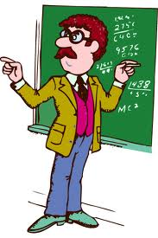
My father’s name is Jack. He is a math teacher in an elementary school. ¹_____ the mornings he always gets up ²______ 6.30. But this is only ³______ weekdays, because ⁴______ the weekend he gets up later.⁵ ______ Tuesdays and Thursdays he has lunch in the school ⁶______ 12.30, because he has lessons both ⁷______ the morning and ⁸______ the afternoon. The other days he finishes work ⁹______ midday, so he comes home for lunch. He sometimes corrects exercises ¹⁰______ the evenings after dinner. My father has his summer holiday ¹¹______ August. But he also has a two-week holiday ¹²______ Christmas, and one week holiday ¹³______ Easter. He has a difficult job, but he loves it!
15. Complete the sentences with the correct time preposition: in, on, at
- What do you usually do ______ the weekend?
- My father doesn’t work ______ Saturdays.
- The film starts ______ 11.00 p.m. and finishes ______ midnight.
- ______ spring, my garden is full of flowers.
- William Shakespeare was born ______ 1564.
- My mum’s birthday is ______ the 5th of May.
- Our office is closed ______ August.
- There are a lot of stars in the sky ______ night.
- ______ Christmas Day children usually receive a lot of presents.
10.I never go home ______ lunchtime
11.My best friend always phones me ______ the evening.
12.______ my birthday I always have a big party.
13.My family sometimes goes skiing for a week ______ Christmas.
14.I love reading in bed ______ Sunday mornings.

16.Write complete questions with the information given:
When/have/you/English lessons? When do you have your English lessons?
What time/have /you/lunch?_________________________________________
When/have/you/summer holidays?___________________________________
What time/you/ get up/weekend?____________________________________
When/your birthday?________________________________________________
What time/go/bed/weekdays?________________________________________
When/go/the/library?/you _________________________________________
When/go/swimming pool?/you ?_______________________________________
When /playground?/you /go/________________________________________

