1.Look and answer

|  |  |  |
| --- | --- | --- |
| Káº¿t quáº£ hÃ¬nh áº£nh cho monkey ' clipart | Káº¿t quáº£ hÃ¬nh áº£nh cho zebra clipart | Káº¿t quáº£ hÃ¬nh áº£nh cho penguin clipart |
| What animal is it ? | What animal is it ? | What animal is it ? |
| *……………………………….* | *……………………………….* | *……………………………….* |
| Káº¿t quáº£ hÃ¬nh áº£nh cho camel clipart | Káº¿t quáº£ hÃ¬nh áº£nh cho kangaroo clipart | HÃ¬nh áº£nh cÃ³ liÃªn quan |
| What animal is it ? | What animal is it ? | What animal is it ? |
| *……………………………….* | *……………………………….* | *……………………………….* |

2.Look and answer

|  |  |  |
| --- | --- | --- |
| Káº¿t quáº£ hÃ¬nh áº£nh cho kangaroo clipart | What can a kangaroo do ? | It can jump. |
| HÃ¬nh áº£nh cÃ³ liÃªn quan | What can a fish do ? | It can ___________________. |
| HÃ¬nh áº£nh cÃ³ liÃªn quan | What can a frog do ? | It can ___________________. |
| Káº¿t quáº£ hÃ¬nh áº£nh cho butterflies clipart | What can a butterfly do ? | It can ______________ |

3.Write

|  |  |
| --- | --- |
| Yes , it is. | No, it isn’t |

|  |  |  |
| --- | --- | --- |
| Káº¿t quáº£ hÃ¬nh áº£nh cho camel clipart | HÃ¬nh áº£nh cÃ³ liÃªn quan | Káº¿t quáº£ hÃ¬nh áº£nh cho kangaroo clipart |
| Is it a camel ? | Is it a zebra? | Is it a kangaroo ? |
| *……………………………* | *……………………………* | *……………………………* |
| Káº¿t quáº£ hÃ¬nh áº£nh cho penguin clipart | Káº¿t quáº£ hÃ¬nh áº£nh cho zebra clipart | Káº¿t quáº£ hÃ¬nh áº£nh cho monkey ' clipart |
| Is it a lion ? | Is it a zebra ? | Is it a monkey ? |
| *……………………………* | *……………………………* | *……………………………* |

4.Look and write

|  |  |  |
| --- | --- | --- |
| Káº¿t quáº£ hÃ¬nh áº£nh cho the monkey play with ball clipart | Káº¿t quáº£ hÃ¬nh áº£nh cho kangaroo jump clipart |  |
| What is the monkey doing ? | What is the kangaroo doing ? | What is the zebra doing ? |
| *………………………………….* | *…………………………………* | *…………………………………* |
| HÃ¬nh áº£nh cÃ³ liÃªn quan | Káº¿t quáº£ hÃ¬nh áº£nh cho lizard sleeping clipart | HÃ¬nh áº£nh cÃ³ liÃªn quan |
| What is the rabbit doing ? | What is the lizard doing ? | What is the fish doing ? |
| *…………………………………* | *…………………………………* | *…………………………………* |
| Káº¿t quáº£ hÃ¬nh áº£nh cho parrot    flying clipart | HÃ¬nh áº£nh cÃ³ liÃªn quan | HÃ¬nh áº£nh cÃ³ liÃªn quan |
| What is the parrot doing ? | What is the monkey doing ? | What is the koala doing ? |
| *…………………………………* | *…………………………………* | *…………………………………* |

5.Look and tick (✓) or cross (🗶)

|  |  |  |
| --- | --- | --- |
| HÃ¬nh áº£nh cÃ³ liÃªn quan | * The rabbit is sleeping. | 🗶 |
| Káº¿t quáº£ hÃ¬nh áº£nh cho lizard sleeping clipart | * The lizard is eating. |  |
| Káº¿t quáº£ hÃ¬nh áº£nh cho elephant walk clipart | * The elephant is walking. |  |
| Káº¿t quáº£ hÃ¬nh áº£nh cho the birds  flying clipart | * The birds are flying. |  |
| HÃ¬nh áº£nh cÃ³ liÃªn quan | * The fish is running. |  |
| Káº¿t quáº£ hÃ¬nh áº£nh cho dolphin clipart | * The dolphin is flying. |  |
| http://www.picturesof.net/_images_300/Squirrel_Climbing_A_Tree_Royalty_Free_Clipart_Picture_090122-111780-508048.jpg | * The squirrel is climbing the tree. |  |
| http://t1.gstatic.com/images?q=tbn:ANd9GcTyzakoTDj-8c5gmcJ5q6w7hQvJSQEajiOgYW489ueCsq7yTmug_UNChQ1KYA | * The horse is running. |  |
| http://www.clipartguide.com/_small/1552-0908-1500-2247.jpg | * The owl is hooting at night. |  |

6.Look at the picture and answer the questions.

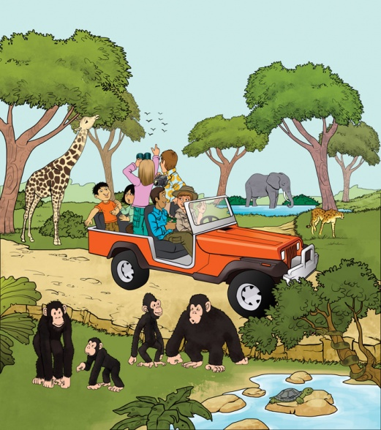

* What is the weather like? *…………………………………………………………..*
* Which animal has the longest neck? *…………………………………………….*
* Which is the smallest animal? *……………………………………………………*
* What color is the car? *…………………………………………………………….*
* How many monkeys can you see? *…………………………………………………*
* How many animals can fly? *……………………………………………………….*
* What is the elephant doing? *……………………………………………………..*
* What is the giraffe eating? *……………………………………………………..*
* Who is watching the birds? *……………………………………………………*
* What is the man next to the driver wearing? *………………………………………………*
* Where is the tortoise?. *………………………………………………*

7.Look and write

|  |  |
| --- | --- |
| Yes, it is  No , it isn’t. | Yes, they are.  No, they aren’t. |

|  |  |  |
| --- | --- | --- |
| http://www.glitters20.com/quotes/wp-content/uploads/2012/12/Animal-Clip-Art-48.jpg | C:\Users\Silvia\Documents\minhas imagens\ILUSTRAÇÕES\CLIPART\ATIVIDADES\a atividades animais\Anoiper1007.gif | http://sr.photos2.fotosearch.com/bthumb/IMZ/IMZ013/cof1932.jpghttp://sr.photos2.fotosearch.com/bthumb/IMZ/IMZ013/cof1932.jpg |
| Is the frog playing the guitar ? | Is the parrot reading a book ? | Are the birds singing ? |
| *……………………………………* | *……………………………………* | *…………………………………* |
| C:\Users\Silvia\Documents\minhas imagens\ILUSTRAÇÕES\CLIPART\ATIVIDADES\a atividades animais\mouse.gif | C:\Users\Silvia\Documents\minhas imagens\ILUSTRAÇÕES\CLIPART\ATIVIDADES\a atividades animais\clipartanimauxsportif2.gif | http://sr.photos3.fotosearch.com/bthumb/CSP/CSP430/k4307519.jpg |
| Is the rat sleeping ? | Is the monkey fishing ? | Is the owl writing ? |
| *……………………………………* | *……………………………………* | *…………………………………* |
|  | C:\Users\Silvia\Documents\minhas imagens\ILUSTRAÇÕES\CLIPART\ATIVIDADES\a atividades animais\basquet.gif | http://sr.photos2.fotosearch.com/bthumb/CSP/CSP164/k1646076.jpg |
| Are the cats fighting? | Is the bear playing volleyball ? | Is the penguin surfing ? |
| *……………………………………* | *……………………………………* | *………………………………* |
| C:\Users\Silvia\Documents\minhas imagens\ILUSTRAÇÕES\CLIPART\ATIVIDADES\a atividades animais\giraffe.gif | http://sr.photos2.fotosearch.com/bthumb/CSP/CSP438/k4384328.jpg | C:\Users\Silvia\Documents\minhas imagens\ILUSTRAÇÕES\CLIPART\ATIVIDADES\a atividades animais\squirrel.gif |
| Is the giraffe walking ? | Is the dog running ? | Is the squirrel kayaking ? |
| *……………………………………* | *……………………………………* | *……………………………………* |

7. Put the words in the correct order to make sentences

|  |  |  |
| --- | --- | --- |
| Káº¿t quáº£ hÃ¬nh áº£nh cho parrot    flying clipart | C:\Users\Silvia\Documents\minhas imagens\ILUSTRAÇÕES\CLIPART\ATIVIDADES\a atividades animais\squirrel.gif | C:\Users\Silvia\Documents\minhas imagens\ILUSTRAÇÕES\CLIPART\ATIVIDADES\a atividades animais\clipartanimauxsportif2.gif |
| flying/The /parrot/is | squirrel/The/is/kayaking. | fishing/The /monkey/is |
| *…………………………………* | *…………………………………* | *…………………………………* |
| http://sr.photos3.fotosearch.com/bthumb/CSP/CSP430/k4307519.jpg | HÃ¬nh áº£nh cÃ³ liÃªn quan | http://www.glitters20.com/quotes/wp-content/uploads/2012/12/Animal-Clip-Art-48.jpg |
| writing/The/owl/is | swimming./The/fish/is | playing/The/guitar./is/frog/the |
| *…………………………………* | *…………………………………* | *…………………………………* |
| Káº¿t quáº£ hÃ¬nh áº£nh cho lizard sleeping clipart | HÃ¬nh áº£nh cÃ³ liÃªn quanHÃ¬nh áº£nh cÃ³ liÃªn quan | C:\Users\Silvia\Documents\minhas imagens\ILUSTRAÇÕES\CLIPART\ATIVIDADES\a atividades animais\Anoiper1007.gif |
| lizard/The/is/slepping./ | The/climbing/are/koalas | The /reading/is/ a /book./ parrot |
| *…………………………………* | *…………………………………* | *…………………………………* |
| Káº¿t quáº£ hÃ¬nh áº£nh cho kangaroo jump clipart | Káº¿t quáº£ hÃ¬nh áº£nh cho the birds  flying clipart |  |
| jumping/The/kangaroo./is | The/flying./birds/are/ | cats/The/are/ fighting |
| *…………………………………* | *…………………………………* | *…………………………………* |

8.Look at the picture of students on a school trip. Write questions and answers.

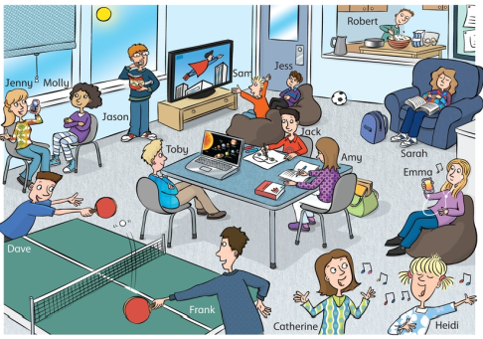

|  |  |
| --- | --- |
| ⇨Jenny/talk to Molly ?/ chat on her phone  Is Jenny talking to Molly ?  No , she isn’t .She’s chatting on her phone.  1.Jason /make dinner ?/eat crisps  *……………………………………………………*  *……………………………………………………*  2.Catherine and Heidi/listen to music?/sing songs  *……………………………………………………*  *……………………………………………………*  3.Sarah/ read a book ?/sleep in a chair  *……………………………………………………*  *……………………………………………………*  4.Toby /do his homework?/watch video clips  *……………………………………………………*  *……………………………………………………*  5.Dave and Frank /clean the table ? /play table tennis  *……………………………………………………*  *……………………………………………………* | 6.Amy/listen to music?/do homework  *……………………………………………………*  *……………………………………………………*  7.Sam and Jess/play computer games?  watch TV  *……………………………………………………*  *……………………………………………………*  8.Robert/make dinner ?/make cake  *……………………………………………………*  *……………………………………………………*  9.Emma/do homework ?/listen to music  *……………………………………………………*  *……………………………………………………*  10.Jack/watch TV ?/ draw picture  *……………………………………………………*  *……………………………………………………*  11it/raining? /sunny  *……………………………………………………*  *……………………………………………………* |

9.Write **is** or **are**

|  |  |
| --- | --- |
| The lizard _______ sleeping. | The boys ______ playing. |
| The cat __________ climbing. | The monkeys ________ singing. |
| The girls _________ clapping. | The dog __________ barking. |
| _________ the bird flying ? | The horse ________ running. |
| The kangaroo ______ not running . | The elephant _________ walking. |
| The koalas __________ climbing the tree. | The zebras _______ running. |
| The eagle ________ flying above the park. | ______ the ducks swimming ? |
| The dog ________ sleeping on the sofa | The squirrel _______ climbing the tree. |

10. Choose the odd one out

|  |  |  |  |  |
| --- | --- | --- | --- | --- |
| 1. England | 1. American | 1. Japanese | 1. Vietnamese | |
| 1. January | 1. October | 1. December | 1. Thursday | |
| 1. Good morning | 1. Goodbye | 1. Good evening | 1. Good afternoon | |
| 1. playing | 1. doing | 1. morning | 1. eating | |
| 1. Library | 1. living room | 1. classroom | 1. computer room |
| 1. lirazd | 1. rabbit | 1. camel | 1. sandwich |
| 1. zoo | 1. school | 1. book | 1. book |
| 1. play | 1. kites | 1. guitar | 1. piano |
| 1. old | 1. young | 1. beautiful | 1. cannot |
| 1. nice | 1. big | 1. read | 1. small |

10.Look , read and tick (✓) or cross (🗶)

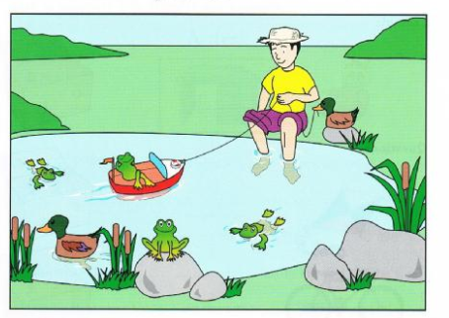

|  |  |
| --- | --- |
| 1. The boy is wearing a hat . | ✓ |
| 1. There are four frogs in the water. |  |
| 1. The boy is wearing a shirt. |  |
| 1. There is a duck next to the boy. |  |
| 1. The boy is playing with a toy plane. |  |
| 1. There is a bird in the boat. |  |
| 1. The boy’s feet are in the water. |  |
| 1. There are two ducks in the water. |  |
| 1. Two frogs are swimming in the water. |  |
| 1. There is a frog on a rock. |  |

11.Check the mistake and correct it.

|  |  |
| --- | --- |
| * The **~~cats~~** is running. | * The lizard are sleeping. |
| ⇨The cat is running. | *.................................................................* |
| * Tony like playing fooball. | * There is tall trees and pretty flowers. |
| *.................................................................* | *.................................................................* |
| * He are kicking the ball. | * I am run and catching the ball. |
| *.................................................................* | *.................................................................* |
| * My friend are playing hike and seek. | * My mom and my dad is walking in the park now. |
| *.................................................................* | *.................................................................* |
| * We is going to the moutain. | * They are going at school. |
| *.................................................................* | *.................................................................* |
| * He is wearing long pant. | * Lily and Lisa likes zebras. |
| *.................................................................* | *.................................................................* |
| * Tony like surfing. | * The kangaroo are jumping. |
| *.................................................................* | *.................................................................* |
| * We sometimes go hiking in Sundays. | * The balls is flying. |
| *.................................................................* | *.................................................................* |