1.Look and write

|  |
| --- |
| swim beach kayak surf windsurf sail waterski snorkel |

|  |  |  |  |
| --- | --- | --- | --- |
| Káº¿t quáº£ hÃ¬nh áº£nh cho beach  clipart | Káº¿t quáº£ hÃ¬nh áº£nh cho swim  clipart | Káº¿t quáº£ hÃ¬nh áº£nh cho waterski clipart | Káº¿t quáº£ hÃ¬nh áº£nh cho kayak  clipart |
| *…………………….* | *…………………….* | *…………………….* | *…………………….* |
| Káº¿t quáº£ hÃ¬nh áº£nh cho sailing  clipart | HÃ¬nh áº£nh cÃ³ liÃªn quan | Káº¿t quáº£ hÃ¬nh áº£nh cho surf  clipart | Káº¿t quáº£ hÃ¬nh áº£nh cho windsurf  clipart |
| *…………………….* | *…………………….* | *…………………….* | *…………………….* |

2. Read and number

|  |  |  |
| --- | --- | --- |
| Káº¿t quáº£ hÃ¬nh áº£nh cho windsurf  clipart | Káº¿t quáº£ hÃ¬nh áº£nh cho waterski clipart | HÃ¬nh áº£nh cÃ³ liÃªn quan |
| Káº¿t quáº£ hÃ¬nh áº£nh cho kayak  clipart | Káº¿t quáº£ hÃ¬nh áº£nh cho surf  clipart | Káº¿t quáº£ hÃ¬nh áº£nh cho sailing  clipart |

|  |  |
| --- | --- |
| 1. He is surfing. | 1. He is waterskiing. |
| 1. She is kayaking. | 1. He is windsurfing. |
| 1. He is sailing. | 1. He is snorkeling. |

3.Look and answer the questions

|  |  |  |
| --- | --- | --- |
|  |  | HÃ¬nh áº£nh cÃ³ liÃªn quan |
| What are they doing ? | What are they doing ? | What is she doing ? |
| *………………………………* | *………………………………* | *………………………………* |
| Káº¿t quáº£ hÃ¬nh áº£nh cho kayaking     clipart | HÃ¬nh áº£nh cÃ³ liÃªn quan | HÃ¬nh áº£nh cÃ³ liÃªn quan |
| What are they doing ? | What is she doing ? | What is he doing ? |
| *………………………………* | *………………………………* | *………………………………* |
|  | Káº¿t quáº£ hÃ¬nh áº£nh cho taking photos on the beach clipart | HÃ¬nh áº£nh cÃ³ liÃªn quan |
| What are they doing ? | What is she doing ? | What is he doing ? |
| *………………………………* | *………………………………* | *………………………………* |
|  |  | HÃ¬nh áº£nh cÃ³ liÃªn quan |
| What is he doing ? | What are they doing ? | What are they doing ? |
| *………………………………* | *………………………………* | *………………………………* |

4. Look , read and write

|  |  |  |  |
| --- | --- | --- | --- |
| Yes, I am. | Yes, he is. | Yes, she is. | Yes, they are. |
| No, I’m not. | No, he isn’t. | No, she isn’t. | No, they aren’t. |

|  |  |  |
| --- | --- | --- |
|  | HÃ¬nh áº£nh cÃ³ liÃªn quan | Káº¿t quáº£ hÃ¬nh áº£nh cho kayaking on the beach  clipart |
| Is he swimming ? | Is he sailing ? | Is he kayaking ? |
| *………………………………..* | *………………………………..* | *………………………………..* |
|  |  |  |
| Are they skipping ? | Are they swimming ? | Is he surfing ? |
| *………………………………..* | *………………………………..* | *………………………………..* |
| Káº¿t quáº£ hÃ¬nh áº£nh cho eating cream on the beach clipart | HÃ¬nh áº£nh cÃ³ liÃªn quan | Káº¿t quáº£ hÃ¬nh áº£nh cho making a sandcastle clipart |
| Is he sailing ? | Are they snorkeling? | Are they flying kites ? |
| *………………………………..* | *………………………………..* | *………………………………..* |

5.Put the words in the correct order to make sentences

|  |  |  |
| --- | --- | --- |
| HÃ¬nh áº£nh cÃ³ liÃªn quan | http://t3.gstatic.com/images?q=tbn:ANd9GcT8DGJbSX2-dkbvl8Ru4ybEnbEKj8GyqWlPjNpNRqUtKojOIEH6Fw | http://3.s3.envato.com/files/161919.jpg |
| are/They /taking /photos./ | is/ She /collecting /sea shells. | are/They /flying/a kite./ |
| *………………………………….* | *………………………………….* | *………………………………….* |
| http://t3.gstatic.com/images?q=tbn:ANd9GcTcxbJYBePJxbwCchsEjJ4m0asZO-IWUQjZt6Dl_HGeUXETthbW |  | Káº¿t quáº£ hÃ¬nh áº£nh cho kayaking     clipart |
| She/book./is/reading/a | They/swimming./are/ | kayaking./They/are |
| *………………………………….* | *………………………………….* | *………………………………….* |
| HÃ¬nh áº£nh cÃ³ liÃªn quan | HÃ¬nh áº£nh cÃ³ liÃªn quan | http://thumbs.dreamstime.com/thumblarge_430/1250712877WiGs8B.jpg |
| snorkeling ./ She/is/ | surfing./She/is/ | She/making/is/a/sandcastle. |
| *………………………………….* | *………………………………….* | *………………………………….* |
| Káº¿t quáº£ hÃ¬nh áº£nh cho waterski clipart | Káº¿t quáº£ hÃ¬nh áº£nh cho he is eating an ice cream on the beach clipart |  |
| waterskiing./He/is/ | She/an/is/eating /ice cream./ | are/They/playing/volleyball./ |
| *………………………………….* | *………………………………….* | *………………………………….* |

6.Look at the picture and complete the sentences using the right verb from the box.

|  |
| --- |
| swimming making playing reading buying talking  digging carrying sunbathing laughing sitting eating |

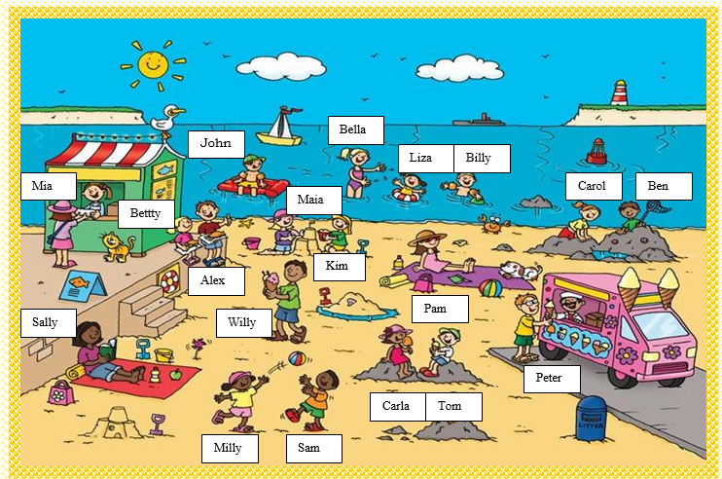

|  |  |
| --- | --- |
| 1- Sally is _______ a book.  2- Milly and Sam are ________ with a ball.  3- Peter is ____________ an ice – cream .  4- Alex and Betty are _____________.  5- Mai and Kim are ________ a sandcastle.  6- Liza and Billy are ______________. | 7- Carol and Ben are ________________.  8- Pam is ______________ .  9-Bella is ______________.  10- Carla and Tom are ________ an ice – cream.  11- Willy is ______________ two ice – creams . 12- John is __________ on a red air bed |

7.Look at the picture and answer

|  |
| --- |
|  |
| 1. What is the man doing ? *…………………………………………………………………...* 2. What is he doing ? *…………………………………………………………………..* 3. What is the dog doing ? *…………………………………………………………………* 4. What is the cat doing ? *………………………………………………………………..* 5. What is she doing ? *………………………………………………………………..* 6. What are they doing ? *………………………………………………………………..* |

8.Complete these sentences with the verbs in brackets. Use the Present continuous

|  |  |
| --- | --- |
|  | 1.It’s summer time and the sun ________________(shine) today.  2.There are three birds _______________ (fly ) in the blue sky and the boat________________(sail) in the sea.  3.Justin ________________(lie) on a towel .He __________  (relax). He _______________ (wear) sunglasses at the moment.  4. Harper __________(wear )a hat.____________(she/build) a sandcastle now ?Yes, she is. She _________(smile)  5.Andrew _________ (not play ).He _______________(run) to the water.  He __________________(laugh)!  6.Tamara _____________(sit) on her towel. She ___________ (read) a very interesting book.  7.Keith ________________ (snorkel ) today .Now he __________(swim)  to the shore.  8.These people __________________ (not have) lunch right now.  9. _______________(they/enjoy) at the beach ? Yes , they are. |

9.Read and match

|  |  |
| --- | --- |
| 1. What is she doing ? | 1. He is making a sandcastle. |
| 1. Are you reading a book ? | 1. She is swimming. |
| 1. What is he doing ? | 1. Yes , I am. |
| 1. What are they doing ? | 1. Yes , they are. |
| 1. Are they windsurfing? | 1. They are surfing. |
| 1. Is she sailing ? | 1. No, he isn’t. |
| 1. Is he snorkeling? | 1. Yes , she is. |

10.Read and circle

a. My father ______________ phoning his friend. He’s reading a book.

|  |  |  |
| --- | --- | --- |
| 1. am not | 1. isn’t | 1. aren’t |

b.________________ the dogs swimming ? No , they aren’t .

|  |  |  |
| --- | --- | --- |
| 1. Am | 1. Is | 1. Are |

c. I am _____________ my homework now.

|  |  |  |
| --- | --- | --- |
| 1. doing | 1. do | 1. does |

d. Are you riding a bike now ? Yes , I _____________ .

|  |  |  |
| --- | --- | --- |
| 1. am not | 1. is | 1. am |

e. Is she painting now ? No , she _______________.

|  |  |  |
| --- | --- | --- |
| 1. isn’t | 1. is | 1. aren’t |

f. Are you swimming ? Yes , I _____________.

|  |  |  |
| --- | --- | --- |
| 1. am | 1. isn’t | 1. aren’t |

g. What _______ she doing ? She is windsurfing.

|  |  |  |
| --- | --- | --- |
| 1. am | 1. is | 1. aren’t |

h. Are they making a sandcastle? Yes , they _____________.

|  |  |  |
| --- | --- | --- |
| 1. am | 1. is | 1. are |

i. Is she flying a kite ? No , she __________.

|  |  |  |
| --- | --- | --- |
| 1. am not | 1. isn’t | 1. aren’t |

j . Are they kayaking? No , they __________.

|  |  |  |
| --- | --- | --- |
| 1. isn’t | 1. is | 1. aren’t |

k._________ Lisa and Lily playing chess ? Yes , they are.

|  |  |  |
| --- | --- | --- |
| 1. Are | 1. Is | 1. Am |

l. What are they doing ? They ___________ playing volleyball.

|  |  |  |
| --- | --- | --- |
| 1. are | 1. is | 1. am |

11. Look at the picture , read the sentences and write the name in the right box.

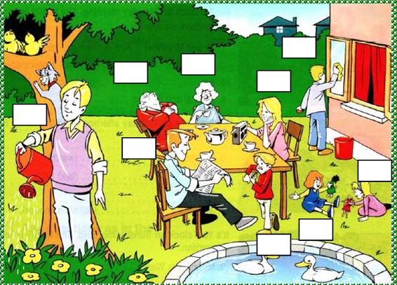

1 – I’m **Carol** . I’m playing with a green doll. I am next to the table.

2- **Harry** is my father .He is reading the newspaper.

3- **Carla** is my mother .She is listening to the radio.

4- **Edith** is my grandmother .She is drinking tea.

5- **William** is my grandfather . He is sleeping.

6- **Peter** is my brother . He is cleaning the windows .

7- **Sally** is my sister .She is playing with me.

8- **Paul** is my cousin .He is eating a sandwich .

9- **Tom** is my uncle. He is watering the plants.

12. Look at the pictures and complete the sentences. Write the present simple or present continuous form of the verb in brackets.

|  |  |
| --- | --- |
|  | * Jack is in his bedroom. He’s lying on his bed and he ________(read) a magazine. * He ___________ (wear) jeans and a T – shirt. * He ___________(not wear) any shoes. * A cat __________ ( sleep ) on a chair. * Jack ___________ (play ) the guitar and he _____________(read) a lot of books. * He ___________ (like ) football – and he ___________(eat)lots of chocolate. * He __________ (not like ) tidying his room ! |

13. Odd one out

|  |  |  |  |
| --- | --- | --- | --- |
| 1. swim | 1. surf | 1. kayak | 1. football |
| 1. volleyball | 1. basketball | 1. handball | 1. football |
| 1. football | 1. gymnastics | 1. hockey | 1. rugby |
| 1. horse riding | 1. ice hockey | 1. skiing | 1. ice skating |
| 1. like | 1. tennis | 1. badminton | 1. golf |
| 1. clean | 1. polluted | 1. safe | 1. river |
| 1. dangerous | 1. read | 1. watch | 1. sleep |
| 1. is | 1. am | 1. are | 1. an |
| 1. speak | 1. song | 1. play | 1. swim |
| 1. beach | 1. lake | 1. river | 1. school |
| 1. sandcastle | 1. flip flops | 1. sunglasses | 1. park |