- Look and write
posters pins shells MP3 player TV DVD player CD player postcards collection camera turn on turn off

 |  | 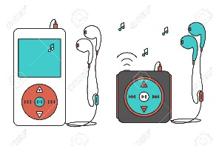 | 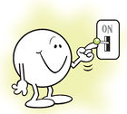
………………………. | ………………………. | ………………………. | ……………………….
 | 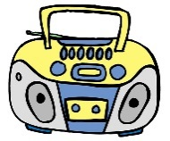
………………………. | ………………………. | ………………………. | ……………………….
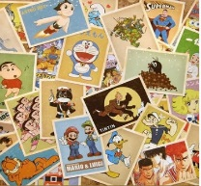 | 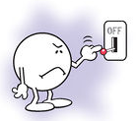 | 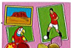
………………………. | ………………………. | ………………………. | ……………………….
2.Complete the sentences using our , your or their
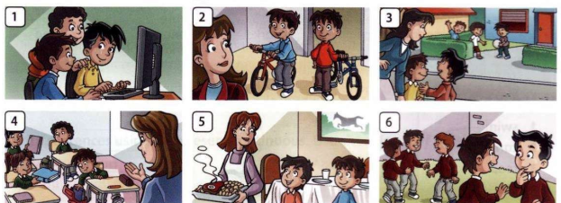
1.Can I use your computer ? 2. Can we ride ________ bikes ?
3.Can we go to __________ house , please ? 4.Can I have _________ homework , please?
4.Can he have dinner at _________ house ? 6.Can we be __________ friends ?
3.Look at the pictures and write questions with Can I or Can we
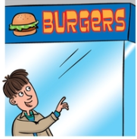 | 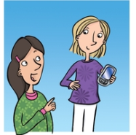 | 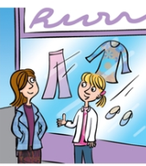
have a burger | use your phone | go to the shops
Can I have a burger? | ……………………………… | ………………………………
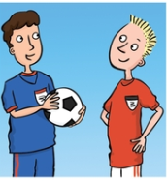 | 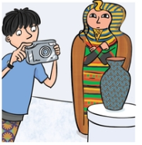 | 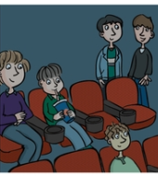
play football | take photos | sit here
……………………………… | ……………………………… | ………………………………
4.Look at the pictures and write requests with Can you ………?
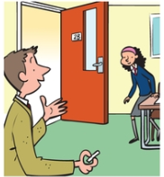 | 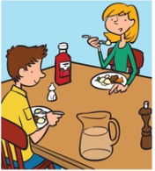 | 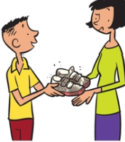
close the door | pass the water | clean my shoes
Can you close the door ? | ……………………………… | ………………………………
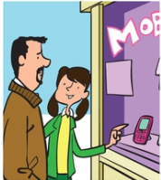 | 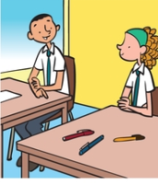 | 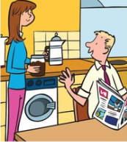
buy me a phone | lend me a pen | make some coffee
……………………………… | ……………………………… | ………………………………
5.Read and match to complete the sentences.
- Can I | - my cousin at the weekend ?
- Can I visit | - a question please ?
- Can I ask | - your pen ?
- Can I go | - the door ?
- Can I borrow | - to the park ?
- Can I close | - help you in the garden ?
6. Write the words to comple the sentences.

help visit what have Can We
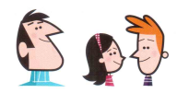

Dad : Tom , what would like to do on Saturday ?
Tom : ____________ we go to the park in the afternoon ?
Dad : Fine .What about you , Lucy? What would you like to do ?
Lucy : Can I ________ Grandma in the afternoon . I want to ________her in the garden.
Dad : OK. _________ can go to the park in the morning and to Grandma’s in the afternoon .What do you want to eat for dinner ?
Tom and Lucy : Can we _________ pizza ?
Dad : Yes !
7.Write sentences to ask permission.
I/have/an apple /? | I /use /your mobile phone /?
Can I have an apple ? | …………………………………………………….
I/turn up/the radio /? | I/turn down / the music /?
……………………………………………………. | …………………………………………………….
I /take /this/pen/? | We/borrow/these books /?
……………………………………………………. | …………………………………………………….
We/turn on /the DVD player/? | We /listen to/the CD player /?
……………………………………………………. | …………………………………………………….
I /borrow/your newspaper /? | I/go/to /the toilet /?
……………………………………………………. | …………………………………………………….
We/go/outside /? | I /listen to music ?
……………………………………………………. | …………………………………………………….
I /play /computer games ? | I /sit down/ ?
……………………………………………………. | …………………………………………………….
I /turn on/the light /? | I /close /the door /?
……………………………………………………. | …………………………………………………….
I /have /some paper /? | I /open/the window /?
……………………………………………………. | …………………………………………………….
I/turn off / the light /? | I /go out /tonight/?
……………………………………………………. | …………………………………………………….
Grandma,/I /go /to /the /swimming pool, please/? | Mom and Dad, / we /go /to/the zoo /today,/ please?
……………………………………………………. | …………………………………………………….
I/use/your ruler /? | I/see/the menu /,please /?
……………………………………………………. | …………………………………………………….
I/have/a /glass of water /? | I/move/the table /?
……………………………………………………. | …………………………………………………….

8.Put the words in the correct order to write requests
pass/sugar/Can/ please/you /the /? | you/Can/please/the /turn up /radio/?
Can you pass he sugar , please ? | …………………………………………………….
Can /curtains /the /open /you/? | you/turn off /the /Can /music /?
……………………………………………………. | …………………………………………………….
turn down/you/television/please/Can/the/? | wash /your/Can/the /car /you/ please /?
……………………………………………………. | …………………………………………………….
Can /go/you/out /for /dinner ,/ Mum? | you/Can /go/to/the /shops/for/me/?
……………………………………………………. | …………………………………………………….
we/play/Can /in /garden /the/? | give/me /Can /you/the/newspaper/?
……………………………………………………. | …………………………………………………….
you/Can/take/letter/this/to/post office/the /? | help/me/Can/you/in/kitchen /the /?
……………………………………………………. | …………………………………………………….
you/Can /put/the butter/the/in /fridge/? | tidy/Can/you/your /room now,/please /?
……………………………………………………. | …………………………………………………….
wait/Can/you/for/me,/please/? | close/Can/the/window/you/?
……………………………………………………. | …………………………………………………….
Can /close /that /door,/ please/you/? | you/Can/bring/you/camera/?
……………………………………………………. | …………………………………………………….
Can/me/you/lend/some money/? | you/Can/help/homework/me /my/?
……………………………………………………. | …………………………………………………….
repair/Can/you/my /watch/? | your/Can/bring/me /a cup /?
……………………………………………………. | …………………………………………………….
turn on /you/Can/the /TV/? | you/Can/turn off /the light /?
……………………………………………………. | …………………………………………………….

9.Look and write : Yes, you can or No , you can’t.
Can I use your book ? | Can I borrow your photos of the  fashion show ?
Yes , you can. | ……………………………………………….
Can I turn on the radio? | Can I use your ruler ?
………………………………………………. | ……………………………………………….
Can I borrow your pen ? | Can I go to the cinema ?
………………………………………………. | ……………………………………………….
Can I turn off the TV ? | Can I go to the toilet , please?
………………………………………………. | ……………………………………………….
Can I speak with Mr. Smith ,  please ? | Can I smoke in this room ?
………………………………………………. | ……………………………………………….
Can I ask you a question? | Can I close the door ?
………………………………………………. | ……………………………………………….

10.Match
- Can you tell me the time , please | - Ok. What’s the problem ? | - ……….
- Can you help me with my homework , please ? | - Yes, sure .Here they are. | - ……….
- Can I use your ruler ? | - Yes, sure .Cheese or egg ? | - ……….
- Can I see your photos ? | - Yes. It’s 6 o’clock. | - ……….
- Can I have a sandwich , please ? | - Ok, but hurry up ! | - ……….
- Can you wait for me ,please ? | - No , you can’t. Sorry .I need it. | - ……….

11. Asking for Permission or Requests
I am thirsty (have ) | I have no money (lend)
Can I have some water, please ? | ……………………………………………….
This suitcase is very heavy. ( help carry) | I can’t do the homework .(help)
………………………………………………. | ……………………………………………….
I want to watch TV .( turn on ) | I don’t know where the post office is.(tell)
………………………………………………. | ……………………………………………….
I need some stamps .(have) | I don’t want to walk .(taxi)
………………………………………………. | ……………………………………………….
I want some help (give me ) | I have to go now (leave)
………………………………………………. | ……………………………………………….
I need a car ( use ) | I need to call Jim. ( call )
………………………………………………. | ……………………………………………….
I can’t buy new clothes .(lend) | I don’t have a pen .( borrow)
………………………………………………. | ……………………………………………….
I don’t want to stand. (sit ) | I want to call my mom ( use )
………………………………………………. | ……………………………………………….
12.Complete the questions using the verbs in the box with Can.
borrow _ close _ help _ play_ go _ open

I’m cold . ________ I _________ the door, please ?
- It’s so hot in here ________ we __________ the window, please ?
- Jack , you have two pencils , ___________ I ________ one , please ?
- I’m very tired. __________I _______ to bed , please ?
- We are bored here.________ we __________ football outside , please?
13.You’re at home. Look at the pictures and write the questions you’ll your parents. and their answers

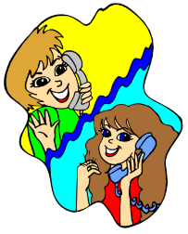 | phone a friend |  | Can I phone a friend ?  Yes , you can.
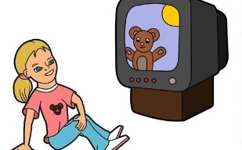 | watch TV |  | …………………………………….?  ……………………………………
 | eat a biscuit |  | …………………………………….?  ……………………………………
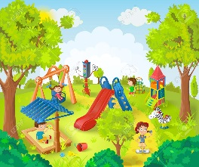 | go to the park |  | …………………………………….?  ……………………………………
 | listen to music |  | …………………………………….?  ……………………………………
 | skip |  | …………………………………….?  ……………………………………

14. Write : his _ her _ our _ your _ their.

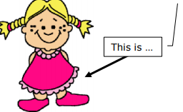 | • ______ name is Lucy.  • ______ eyes are brown.  • She has long hair.  • She has a brother, ______ name is Leo.  • ______ (= Lucy’s) dress is red.
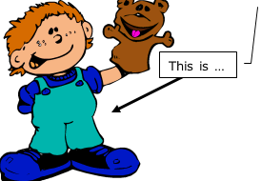 | • ______ name is Paul.  • ______ shoes are big and blue.  • ______ puppet is a bear  .  • Paul has two sisters, ______ names are Patty and Pippa.
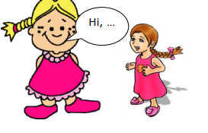 | • "Hi, ______ name's Ella.  • This is ______ friend, ______ name's Katie.  • Katie and I love many colors, but ______ favorite is pink.  • Katie is pretty, ______ hair is brown and ______ eyes are green."
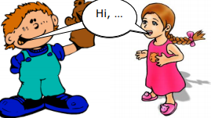 | - "Hi, ______ names are Lisa and Joe.  • We have two cats, ______ names are Mr Little and Miss Milk. We go to school, ______ teacher is Ms .Miller."

