1.Look and write
read comics take photos play chess fish
play basketball play volleyball do gymnastics play guitar
shop cook play the piano visit my family

 | 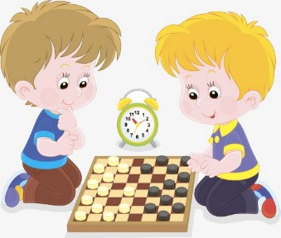 |  | 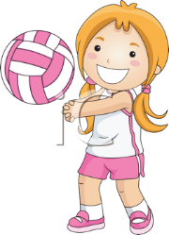
take photos | ………………………… | ………………………… | …………………………
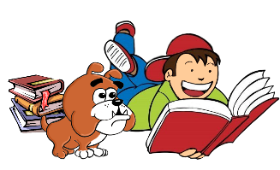 | 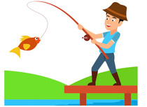 | 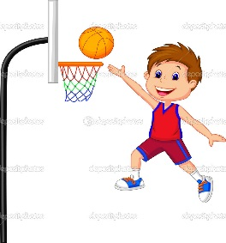
………………………… | ………………………… | ………………………… | …………………………
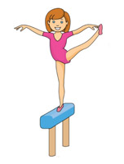 | 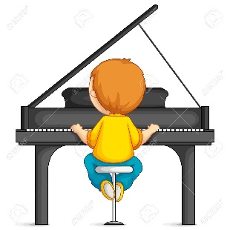 | 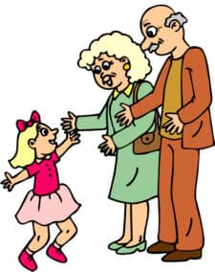 | 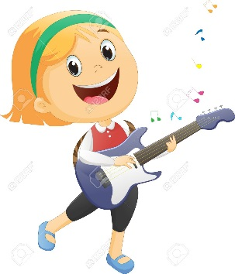
………………………… | ………………………… | ………………………… | …………………………
2. Look and answer the questions.
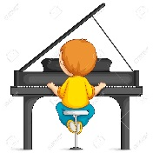
What does he like doing ? | What does she like doing ?
He likes playing the piano. | ……………………………………..
 | 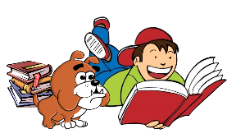
What does she like doing ? | What does he like doing ?
…………………………………….. | ……………………………………..
What does she like doing ? | What does he like doing ?
…………………………………….. | ……………………………………..
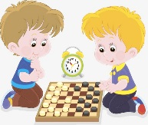
What do they like doing ? | What does he like doing ?
…………………………………….. | ……………………………………..

3. Look and write
Yes, I do. | Yes, she does. | Yes, he does. | Yes, they do
No, I don’t. | No, she doesn’t. | No, he doesn’t. | No, they don’t.
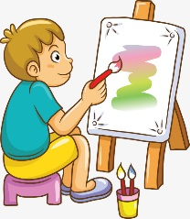 | 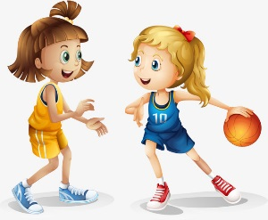
Does he like painting ? | Do they like playing basketball?
Yes, he does. | …………………………………………
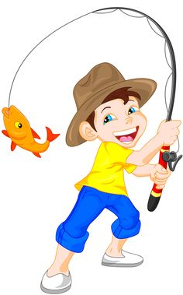
Does he like fishing ? | Does she like shopping ?
………………………………………… | …………………………………………
 | 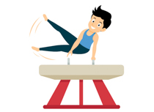
Do you like taking photos ? | Does he like doing gymnastics ?
………………………………………… | …………………………………………

4.Look and write.
likes doesn’t like
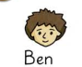 | play basketball  fish | shop  cook
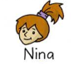 | play the piano  cook | take photos  fish
 | play volleyball  play chess | cook  read comics
 | shop  doing gymnastics | play the guitar  play volleyball

1.Ben likes fishing.  2.Ben doesn’t like shopping.  3……………………………  ………………………………  4.……………………………  ……………………………… | 1…………………………………….……………......  2.…………………………  ………………………….  3.……………………………………………….…….  4.……………………………………………….…… | 1……………………………………………….  2.………………………………………………..  3.……………………………………………….  4.………………………………………………. | 1……………………………………………….  2.…………………………………………  3.……………………………………………  4.……………………………………………

5. Put the words in the correct order to make sentences.
 | Anna/singing./likes | Anna likes singing.
 | volleyball./playing/Lisa/likes | ______________________________
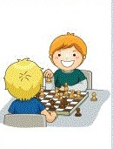 | playing/chess./Ben/and/ Tim/like / | ______________________________
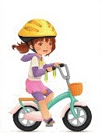 | riding/ a /bike . /She/likes/ | ______________________________
 | Lily/swimming./likes/ | ______________________________
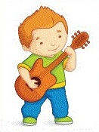 | playing/guitar./the/Tony/likes | ______________________________
 | dancing./like/I | ______________________________

6. Read and answer.
 |  | 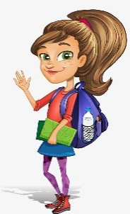
Lucy | John | Sophia
I like cooking and playing chess but I don’t like watching TV . | I love playing football. I don’t like writing but I like playing chess too. | I like riding a bike but I don’t like dancing.  I love swimming.

- What does Lucy like doing ? ……………………………………………………
- Does Lucy like watching TV ? …………………………………………………
- Does Lucy like playing chess ? ………………………………………………..
- Does John like writing ? ………………………………………………………..
- What does John like doing ? …………………………………………………
- Does John like playing football ? …………………………………………..
- What does Sophia like doing ? ………………………………………………
- Does Sophia love swimming ? ………………………………………………
- Does Sophia like dancing ? …………………………………………………
7. Choose the correct option to complete the dialogs below.
A: I can't wait for the weekend.
B: Me, neither. What do you like __________do/doing on weekends?
A: I like ________ play/playing in a band. I _______ play/playing in a band every Saturday night.
B: Huh. What else do you do?
A: Well, when I'm at home, I ________ do /doing yoga.
B: _______ Do/Doing yoga is really relaxing!!
8. One of the two sentences is right. Decide which one
a) I like go to the cinema.  I like going to the cinema. | b)Do you like play videogames?  Do you like playing videogames?
c) He likes singing.  He like singing. | d) Do Tom like dancing?  Does Tom like dancing?
e) Why do you like learning  in the library?  Why you like learning  in the library? | f) She likes playing volleyball.  She like playing volleyball.
g) Do Sarah and Peter like  swimming?  Does Sarah and Peter like  swimming? | h. She like playing chess.  She likes playing chess.

9. Complete the sentences with "like" or a verb in gerund.
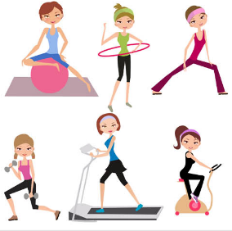
They really ________ going to the gym. | I don't like ___________ football.
 | 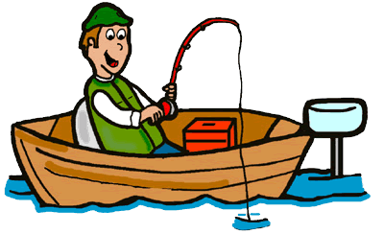
Do you like __________________? | He doesn’t like ________________.
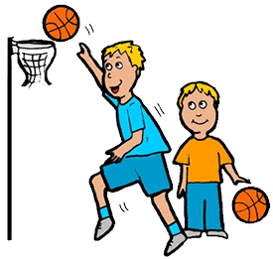
Do they like __________________? | Does he ____________ running ?
 | 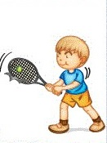
He ______________ watching cartoons. | Tony likes _________ tennis .

10. Make sentences using the words bellow, adding -ing to the verb and the auxiliary do/does when necessary. In negative sentences use the short negative form don't/doesn't.
a) I / not like / go / to the cinema.
I don’t like going to the cinema.
b) You / like / cook?
……………………………………………………………………
c) He / like / play / with his friends.
……………………………………………………………………
d) She / like / shop?
……………………………………………………………………
e) My parents / not / like / watch TV.
……………………………………………………………………
f) Peter / not / like / go / to the beach.
……………………………………………………………………
g) You / like / play chess?
……………………………………………………………………
h) Ana and Josh / really / like / run / in the park.
……………………………………………………………………
g. Why / you / like / do gymnastics?
……………………………………………………………………
h. She / like / play /the piano ?/
……………………………………………………………………
i. My sister / not / like / cook./
……………………………………………………………………
j. Why / she/ like /play /the guitar?
……………………………………………………………………

11. Ride , climb or play ? Write the words.
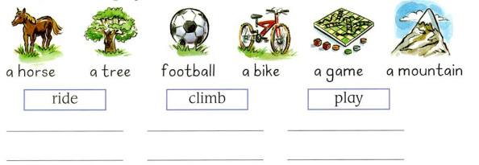
12.Read and circle the correct words.

1.She like/likes cooking. | 7.My sister like/likes doing gymnastics
2.My brother like/likes watching TV. | 8.He likes/like riding a bike.
3.They doesn’t like / don’t like playing football. | 9.Lucy doesn’t like /don’t like swimming.
4.Lily and Anna like/likes shopping. | 10.I don’t like/doesn’t like fishing.
5.Do/Does she like listening to music ? | 11.My mother likes/like cooking.
6.She likes/like playing basketball . | 12.Does /Do Lucy and Anna like playing the piano ?
12.Complete the sentences using like + ing
read swim play (x2)

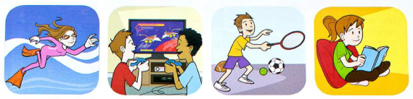
Here is some pictures of my friends doing their favorite activities .Anna likes swimming. She’s very good at it! Tony and Peter _____________ computer games. They play their computer games for hours and hours ! Tom _____________ tennis. He loves sport ! Lucy ___________ books. She is always reading ! What do you like doing at the weekend !
13.Read and number
