Test Unit 2
1. Look and write
posters pins shells MP3 player TV DVD player CD player postcards collection camera turn on turn off

1 | 2 | 3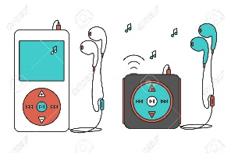 | 4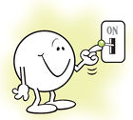
5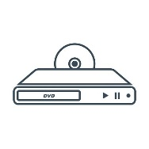 | 6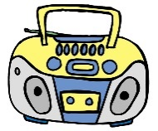 | 7 | 8
9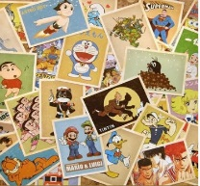 | 10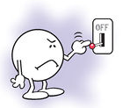 | 11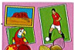 | 12

2.Complete the sentences using our , your or their
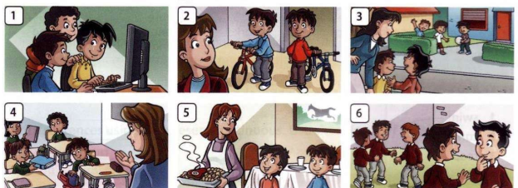
1.Can I use your computer ? 2. Can we ride _______ bikes ?
3.Can we go to _______ house , please? 4.Can I have ___homework , please?
4.Can he have dinner at _____ house ? 6.Can we be __________ friends ?

3. Put the words in the correct order to write requests
1. Can /door /the /open /you/ please ?
2. wait/Can/you/for/me,/please/?
3. you/Can/ please/ put on/coat,/ your?
4. turn on /I/Can/the /TV/?
5. you/Can/turn off /the light /?

2. Choose and write the correct sentence.
a) I like go to the cinema.  I like going to the cinema. | b)Do you like play videogames?  Do you like playing videogames?
c) He likes singing.  He likes sing. | d) She likes play volleyball.  She likes playing volleyball.
g) Does he like takeing photos?  Does he like taking photos? | h. She like playing chess.  She likes playing chess.

3.Read and circle the correct words.
1.She like/likes cooking. | 6.My sister like/likes doing gymnastics
2.They doesn’t like / don’t like playing basketball. | 7.Lucy doesn’t like /don’t like swimming.
3.Lily and Anna like/likes shopping. | 8.I don’t like/doesn’t like fishing.
4.Do/Does she like reading books ? | 9.My mother likes/like cooking.
5.She likes/like playing chess. | 10.Does /Do Lucy and Anna like playing the piano ?

