**STARTER**

**Ex1: Write the name of family members.**

|  |  |  |  |
| --- | --- | --- | --- |
| Ông: | Bà: | Bố: | Mẹ: |
| Anh: | Chị: | Chú: | Dì: |
| Anh em họ: | |

**Ex2: Write adjective of comparative**

1. The elephant is ____________ (big) than the mouse.
2. The giraffe is _____________ (tall) than the zebra.
3. The goat is ______________ (small) than the horse.
4. The horse is _____________ (fast) than the cow.
5. Grandpa is _____________ (old) than Dad.
6. Sister is ______________ (young) than mother.

**Ex3: Write the name of months.**

|  |  |  |
| --- | --- | --- |
| Tháng 1: | Tháng 2: | Tháng 3: |
| Tháng 4: | Tháng 5: | Tháng 6: |
| Tháng 7: | Tháng 8: | Tháng 9: |
| Tháng 10: | Tháng 11: | Tháng 12: |

**Ex5: Write the sum**

1. eight + three = __________ 2. six + six = ______________

3. nine + four = __________ 4. seventeen + three= __________

5. seven + eight = __________ 6. fifteen + five =_____________

7. twenty + twenty = __________ 8. fifty+ thirty =______________

Ex6: Write in words and complete the sum.

1. 4+4= four and four is eight
2. 7+6= _________________________.
3. 11+12=________________________.
4. 20+20=________________________.
5. 13+15=________________________.
6. 50+30=________________________.
7. 20+70=________________________.
8. 40+60=________________________.
9. **Ex4: Write numbers**

|  |  |  |  |  |
| --- | --- | --- | --- | --- |
| 1 | 2 | 3 | 4 | 5 |
| 6 | 7 | 8 | 9 | 10 |
| 11 | 12 | 13 | 14 | 15 |
| 16 | 17 | 18 | 19 | 20 |
| 30 | 40 | 50 | 60 | 70 |
| 80 | 90 | 100 | 21 | 22 |

**Review Unit 1**

**Ex1: Write the name of country**

|  |  |  |
| --- | --- | --- |
|  |  |  |
|  |  |  |

**Ex2: Write the name of seasons**

|  |  |  |  |
| --- | --- | --- | --- |
| Xuân: | Hạ | Thu | Đông |

**Ex3: Write days of week**

|  |  |  |
| --- | --- | --- |
| Thứ 2: | Thứ 3: | Thứ 4: |
| Thứ 5: | Thứ 6: | Thứ 7: |
| Chủ Nhật: |

**Ex4: Write is / are/ am**

1. He ______ from Australia.
2. I ________from Viet Nam.
3. They _______ from Korea.
4. We ________ from Mexico.
5. She _______from Thailand.
6. John_______from America.
7. Meri________ from Japan.
8. Leo and Amy ________from Mexico.

**Ex5: Write He’s/ She’s / We’re/ They’re/ I’m**

1. My name’s Lan. ________ from Viet Nam.
2. His name is Max. _________from Australia.
3. Her name is Amy . ________from Mexico.
4. I and Holly are friends. __________from Australia.
5. Eun-sol and Mon are cousin. _________from Korea.

**Ex6: Write the question.**

1. ________________________? I’m from Vietnam.
2. ________________________? He is from Mexico.
3. ________________________? She is from Thailand.
4. ________________________? They are from America.
5. ________________________? We are from China.
6. ________________________? I’m ten years old.
7. ________________________? She is eleven years old.
8. ________________________? He is twelve years old.
9. ________________________? My mother is fifty years old.
10. ________________________? My father is fifty five years old.
11. _________________________? My favorite season is summer.
12. __________________________? My birthday is in June.

**Ex7: Read and fill in the blank:**

My name______ Han. I’m ______Viet Nam. I _______in Binh Dương. I_____ ten years old. I’m _____ class 5A . I’m a student ____ PHA primary School. My birthday ____in January. My favorite season ________ Fall.

This is my friend. Her name _____ Dung. She ____ eleven year old. She _____tall and pretty. She _____ a good student.

Ex9: Write about your shelf: Viết về bản thân em ra vở

|  |  |  |
| --- | --- | --- |
|  |  |  |
|  |  |  |

**Ex8: Phonics**

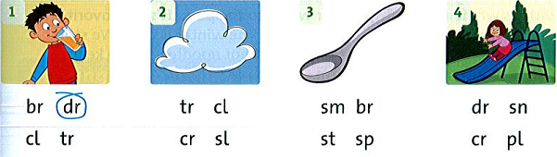

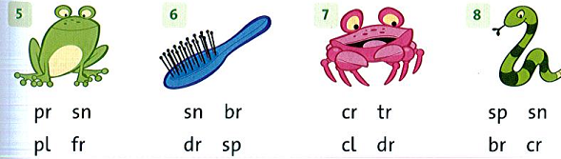

**Review Unit 2: My Weekend**

**Ex1: Write the name of picture.**

|  |  |  |
| --- | --- | --- |
|  |  |  |
|  |  |  |
|  |  |  |
|  |  |  |

|  |  |
| --- | --- |
| **Like + Ving: thích**  S1( I/You/We/ They)  S2( She/ he/ It) | |
| **S1+ like/ don’t like+ V-ing.** | **S2+ likes/ doesn’t like+ V-ing.** |
| **Do + S1+ like + V-ing?** | **Does + S2+ like + V-ing?** |

**Ex 1:Write like or likes**

1. 1 I ***like/ likes*** listening to music.
2. She ***like/ likes*** reading comics.
3. He ***like/ likes*** watching TV.
4. They ***like/ likes*** fishing
5. We ***like/ likes*** dancing.
6. My mother ***like/ likes*** cooking..

**Ex 2:Write don’t like or doesn’t like**

1. I ***don’t / doesn’t like*** shopping.
2. Lan and Hoa ***don’t / doesn’t like*** fishing
3. I and Holly ***don’t / doesn’t like*** dancing.
4. My mother ***don’t / doesn’t like*** cooking..
5. My brother ***don’t / doesn’t like*** playing chess.
6. My sister ***don’t / doesn’t like*** taking photos.

**Ex3: Look and write**

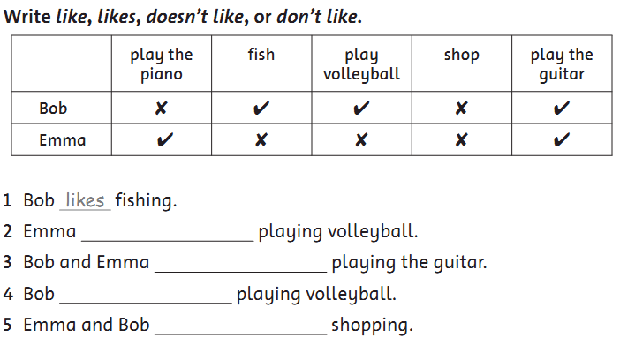

**Ex4: Match**

e

1. Do you like taking photo? a. Yes , we do.
2. Does Amy like playing chess? b. No, she doesn’t.
3. Does Max like play basketball? c. Yes, he does.
4. Do Mom and Dad like play badminton? d. No, they don’t.
5. Do you and Hoa like cooking? e. No, I don’t.

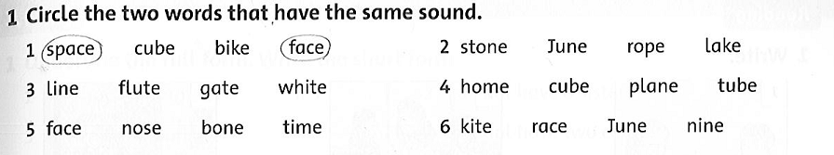

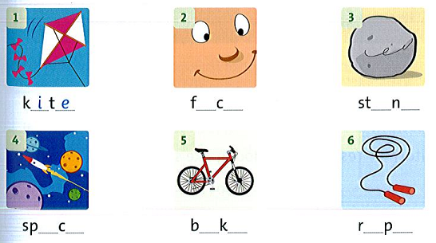

**Review Unit 3: My things**

**Ex1: Write the name of picture.**

|  |  |  |
| --- | --- | --- |
|  |  |  |
|  |  |  |
|  |  |  |
|  |  |  |

**Ex2: Complete the sentence with words in the box:**

|  |
| --- |
| **use watch play listen have open help** |

1. Can you________me with my homework?

Yes, ________can.

1. Can he ________ dinner at our house?

No, ______can’t

1. Can she ________your computer?

Yes, _______can.

1. Can I _________TV?

No ,_______can’t

1. Can I _________ to music?

Yes, _____can.

1. Can you ___________basketball with me

Yes, _____can

1. Can you _______the door, please?

Yes, ______can.

**Ex3: Circle A,B,C or D**

1. How many ____________does he have?
2. shells B. shell C. a shell D. the shells
3. ________Khoa have a collection?
4. Do B. Are C. Does D. Is
5. How many pins __________Anh have?
6. are B. does C. is D. do
7. She _________ fifty pins.
8. have B. having C. haves D. has

**Ex4: Write words with :** ar

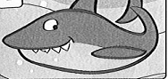 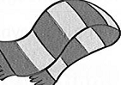 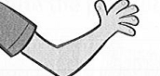  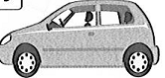 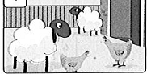

______ ______ ______ _______ _______ __________

**Ex5: Fill in the blank**

1. _______you like playing chess? Yes, I ____.
2. _______she like taking photo? Yes, she ______.
3. _______he like cooking? No. he _________.
4. ________Lam and nam like swimming? Yes, they ______.
5. _________Oanh like reading comics? No, she __________.
6. _________Duy have lots of pin? Yes, _______does.
7. How _________posters does Chi have?
8. She _________one hundred posters.

**Ex6: Write the question**

1. __________________________? I have one shell.
2. __________________________? He has three puppets.
3. __________________________? She has eight postcards.
4. __________________________? Yes, I do. I have a brother.
5. __________________________? No, he doesn’t have any sister.

**Ex7: Write the correct words:**

|  |
| --- |
| season is good doing playing beautiful shopping likes |

Gaomin is ten years old. He____from Singapore. Singapore is a ________country.

Gaomin _________living in Singapore. His favorite __________is summer. He likes __________gymnastics. He likes ___________basketball,too. He doesn’t like __________. He is a ________student.

**Review Unit 4: We’re having fun at the beach**

**Ex1: Write the name of picture.**

|  |  |  |
| --- | --- | --- |
|  |  |  |
|  |  |  |
|  |  |  |
|  |  |  |

|  |  |
| --- | --- |
| **Present grogressive( Thì hiện tại tiếp diễn)** | |
| S + is/ are/ am + V-ing. | S + is/ are / am not + V-ing. |
| Is/ Are/ Am + S+ V-ing? Yes/ No | |

**Ex2: Look, read and circle:**

|  |  |  |
| --- | --- | --- |
| 1. a. He is eating .   b. He is eat.  c. He eating. | 1. a. She isn’t reading   b. She is reading.  c. She reading. | 1. a. We is windsurfing.   b. We are windsurf.  c. We are windsurfing. |
| 1. a. I’m take ing photo.   b. I’m taking photo.  c. I taking photo. | 1. a. They are surf.   b. They is surfing.  c. They are surfing. | 1. a. They’re kayaking.   b. They’re snorkeing.  c. They’re waterskiing |

**Ex3:**

1. I/ sail : **I am sailing.**

1. He/ swim/ : ______________________.
2. She / cook/: _______________________.
3. My friend/ shop/: _______________________.
4. Nam/ not/ watch TV/: _______________________.
5. They/ not/ play basketball/: _______________________.
6. We/ read books/: ________________________.
7. The boy/ wear a hat/ ________________________.

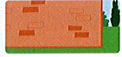 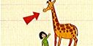   

_________ _________ __________ ____________ ___________

**Review Unit 5: A funny monkey**

**Ex1: Write the name of picture.**

|  |  |  |
| --- | --- | --- |
|  |  |  |
|  |  |  |
|  |  |  |
|  |  |  |
|  |  |  |
|  |  |  |

**Ex2: Look, read and circle:**

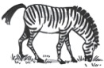1. Is the zebra eating? A. Yes, it’s. B. Yes , it is. C. No, it is.

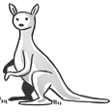2. Is the kangaroo sleepping? A. No, it aren’t. B. No, it is. C. No, it isn’t.

3. Are the penguins flying?

A. Yes, they are B. No,They aren’t. C.No, they are

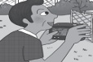4. Is he taking photo? A. Yes, it is. B. Yes, he is. C. Yes, she is.

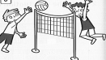5. Are they playing basketball?

A. No, they are B. Yes, they are C. No, they aren’t

