REVISION FOR GRADE 4

- Look at the table and answer the questions by writing True (T) or False (F).
Monday | Tuesday | Wednesday | Thursday | Friday | Saturday | Sunday
English | Art | English | PE | English | PE | Swimming
Music | PE |  | Music | Football | English | Fishing
Math | Music |  |  |  | Art | Camping
Football |  | Math |  | Art | Math
Art |  |  |  |  | Music | Going out
- Marry has math on Monday and Tuesday. _____________
- Marry has art in three days.______________
- Marry does not have PE on Sunday.______________
- Marry goes camping on Wednesday. _______________

- Choose the correct answer.
- I have math …………..Monday. A. In B. on C. at D. of
- It is time for football. Put ………….your PE clothes now. A. On B. in C. at D. of
- These …………..our bags. A. Is B. am C. are D. be
- That ………….my book. A. Is B. am C. are D. be
- We have English class …………8 o’clock on Friday. A. At B. in C. on D. of
- Those are …………….bags. We have just gone out for few minutes.
- Their B. our C. she D. he
- ……………..is a doctor. A. They B. Their C. Our D. She
- We play football ………………the sports field. A. in B. on C. at D. about
- She ………………..to bed at 9 o’clock. A. get B. gets C. go D. goes
- He ………………..dinner at 6 o’clock. A. Have B. has C. get D. gets
- I ……………..my coat. A. Go B. goes C. take D. takes
- She ………………….dressed. A. Have B. has C. get D. gets

III. Fill a/an/ Ø

- ………………..purple bag
- ……………….new books
- ……………….good teacher
- ……………….red pen
- …………….....blue tables
- …………….....orange hat
- …………….....ice-cream
- …………….....P.E. clothes

IV. Write the answers.
1. 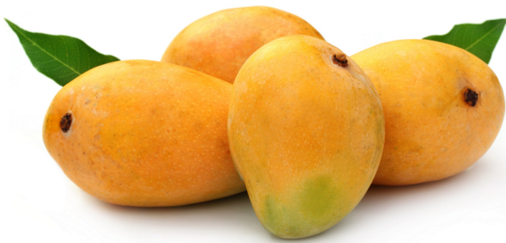✓ Do you have mangoes? …………………………………………………..
2.  How many pillows are there? …………………………………………….
3. 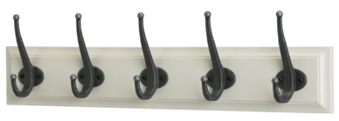 What are these? …………………………………………………….
4. 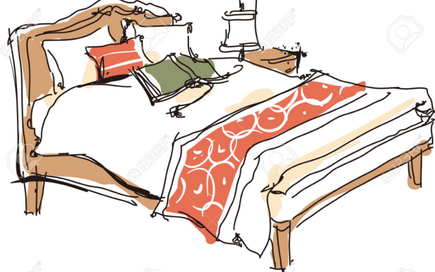 Where are the books? ……………………………………………..
5. 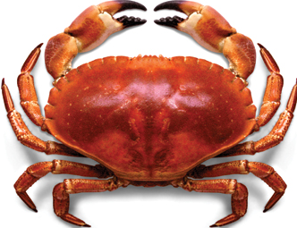 Is it a frog? ……………………………………………..
6.  What does she like? …………………………………….
7.  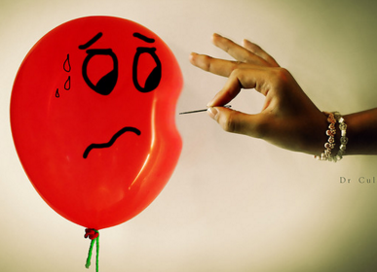 Does he like balloons? ……………………………………
8.  What do you like? …………………………………….
9. 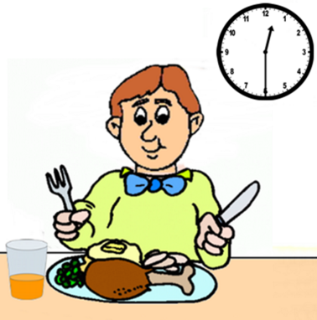 When does he have lunch? 10. 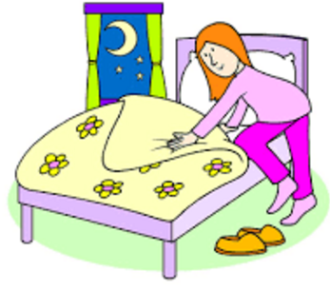 When do you go to bed?

…………………………………………………….. ……………………………………………………..
V. Look at the picture and do the task.
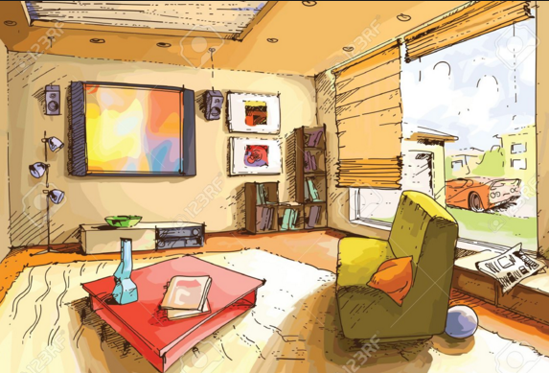
True (T) or False (F)
1. It is a living room. ………. 2. There is a T.V. on the wall. ………
3. The computer is in the room. ……… 4. The toy box is near the window. …….…
Answer.
1. Is there a sofa in the room?
2. How many books are there on the table?
3. Where is the ball?
4. How many pictures are there on the wall?
5. Is there a shelf in the room?
6. Where is the pillow?

VI. Write the words.
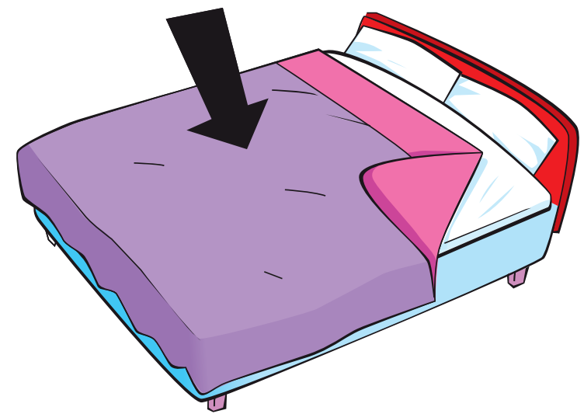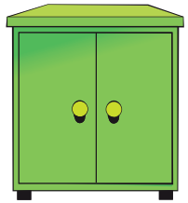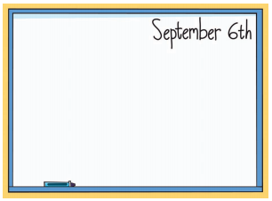

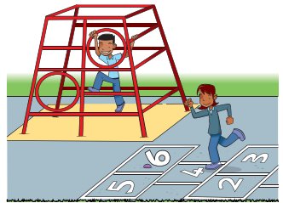

VII. Write sentences with: like/ don’t like / likes / doesn’t like
1. Rosy  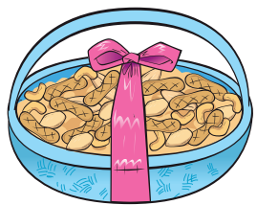 2. Tim  
………………………………………………..………. ………………………………………..……….
3. Mom  4. Billy 
………………………………………………..………. ………………………………………..……….
VIII . Look at the table and answer. Write the words.

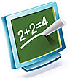


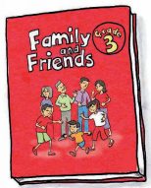
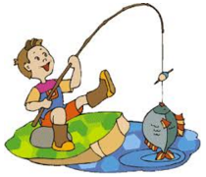
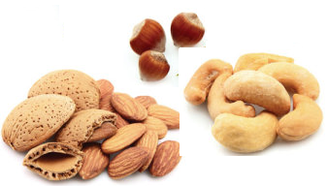
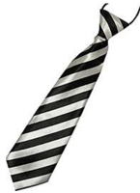


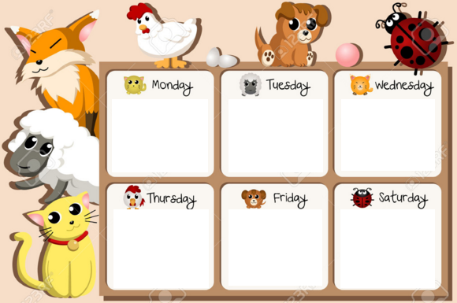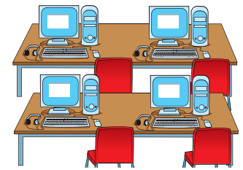
1. What do we have on Monday? …………………………………………
2. Do we have English on Thursday? …………………………………….
3. When do we have music? ……………………………………………..
4. Do we have art on Wednesday? ……………………………………….
5. What do we have on Friday? …………………………………………..
6. When do we have English? ……………………………………………
7. What do we do on Saturday? ………………………………………….
IX. Make sentences.
1. Andy 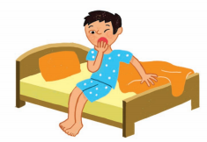 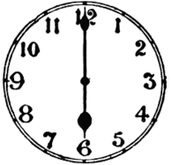 ……………………………………………………………
2. Dad 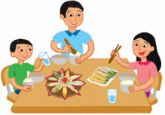 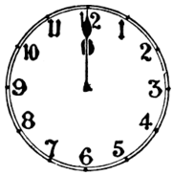 …………………………………………………………………..
3. Hoa  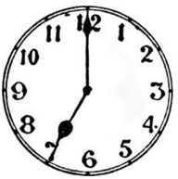 …………………………………………………………………….
4. Nam 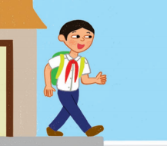 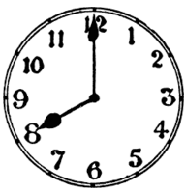 …………………………………………………………………..
5. I  

