REVIEW- COVID 19
Ex 1: Nhìn, Viết các từ sau đó đọc to:
Phonics:
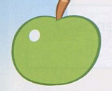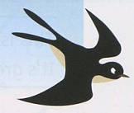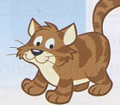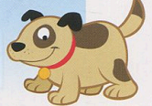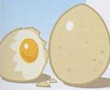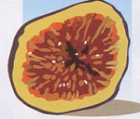
_________ _________ _________ _________ ________ ________
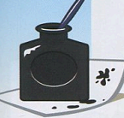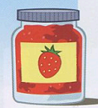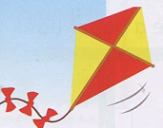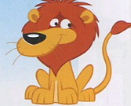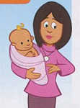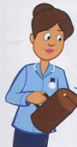
_________ _________ _________ _________ _________ ________
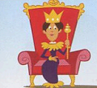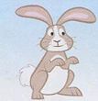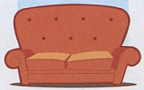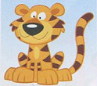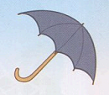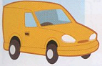
_________ ________ _________ _________ _________ _________
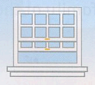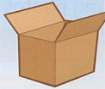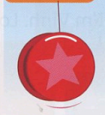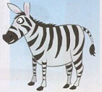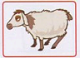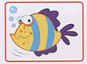
_________ __________ _________ __________ _________ __________
Unit 1: School things
1. 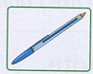  Pen_ | 2. 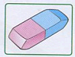  _________ | 3. 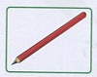  ___________ | 4. 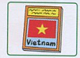  ___________
5. 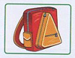  _________ | 6. 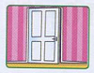  _____________ | 7. 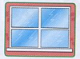  ____________ | 8.
Unit 2: Toys
1. 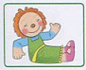  ___________ | 2. 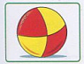  __________ | 3.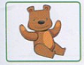  ___________ | 4. 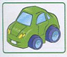  ___________
- 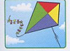  ___________ | 6. 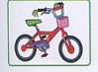  _____________ | 7. 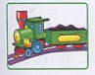  ___________
Unit 3: Body
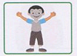  1.__________ | 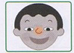  2.__________ | 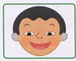  3.__________ | 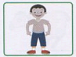  4.__________
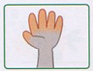  5.___________ | 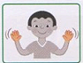  6.____________ | 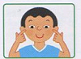  7.____________
Unit 4: Jobs
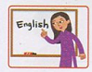  1.___________ | 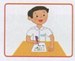  2.___________ | 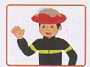  3.__________ |   4.__________
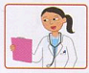  5.__________ | 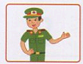  6.___________ | 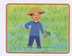  7.____________ | 8.___________
Unit 5:In The park
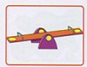1.______ | 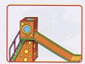2.______ | 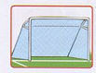3.________ | 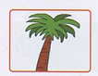4._______
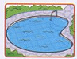5.________ | 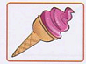6._______________ |  | 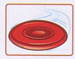7.________

Unit 6: family
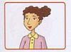1._________ | 2.________ | 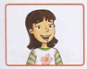3.________ | 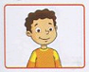  7.__________
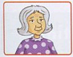4._________ | 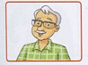5._______ | 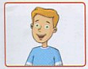6.________

Unit 7:
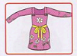1._________ | 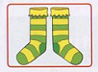2.________ | 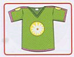3.________ | 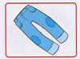7.________
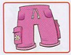4._________ | 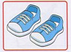5._______ | 6.________

Phụ huynh cho các bé Đọc to tên các tranh, viết thuộc tất cả các từ có trong tranh. Có thể copy nhiều lần cho thuộc.

